Create 1CapApp Icon On Your Cell Phone

First, type in your custom 1CapApp URL in your phone/tablet’s web browser:

Click on your settings button on your cell phone and click on Add to homescreen:
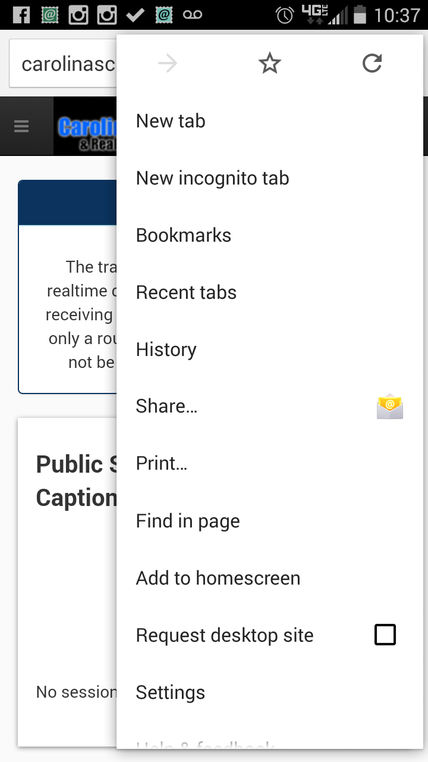

The next page will reveal the Icon has been added to your home screen:
