How To Send/Receive Attachments

Important: This feature will only work for sessions that require a user name and password.

The viewer will log into their session with their user name and password.
At the top, right of their view page, there is a paper airplane icon. Viewer will click to send file.
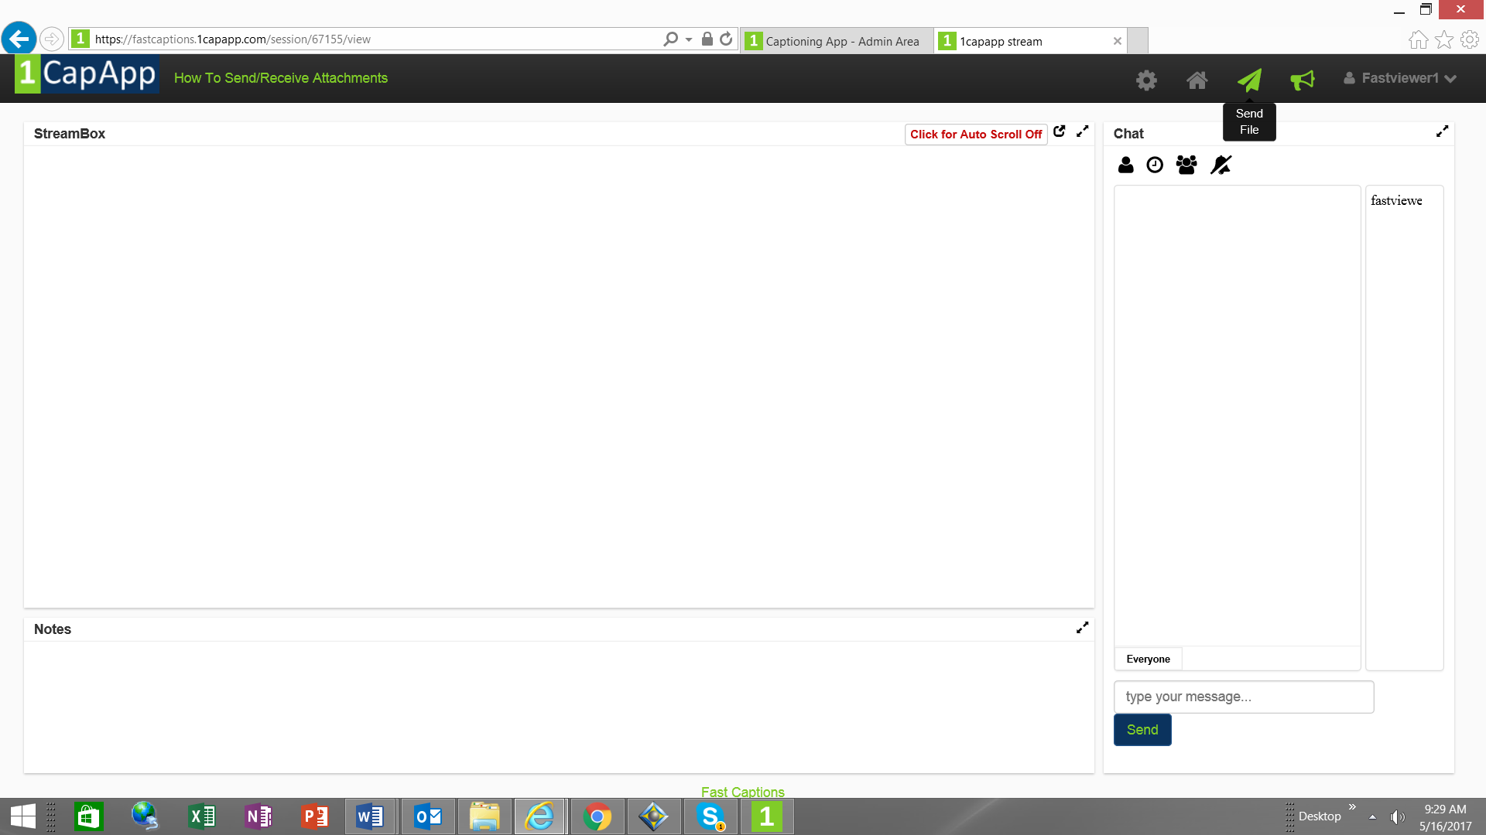

(Go to next page)
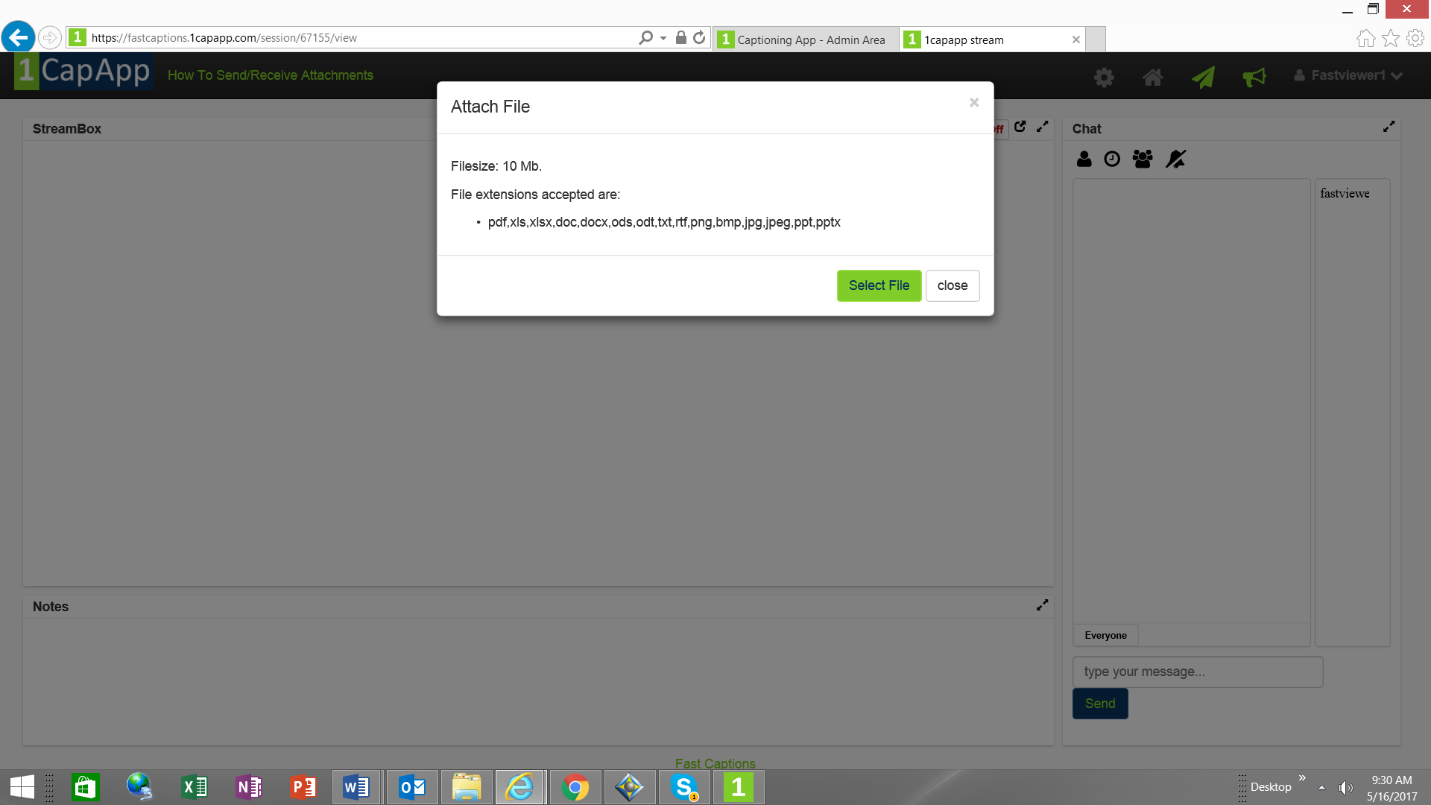
Viewer will select the file they would like to send and then press the send file button.

The captioner will receive the items sent back at their dashboard.
So captioner will go to www.1capapp.com and log in with their user name and password.
Go to setup sessions.
Click on status button.
(Go to next page)

Under action column, there will be a prep button
