Best Case Configuration for 1Net
Computer running Windows 7, 8, 10.
1Net will not run on a MAC, tablet or cell phone.
Processor: Dual core @ 1.2 GHZ
RAM: 2GB
Free disk space: 100MB
Pick a wireless adapter that supports the 1Net hosted network.
Test the integrated WiFi of your computer or a USB adapter.
We have tested with success "Netis 300 Mbps Wireless N USB Adaptor WF2123"

Important Note: Many USB WiFi adapters do not offer a good speed for the hosted network. It's very important to choose an adapter that we have tested and reported to work as expected.

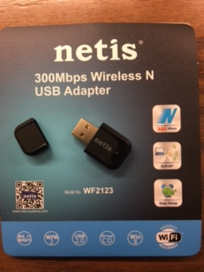
1Net Enterprise Training
1CapApp will provide free training for 1Net at an executive level to current account holders who buy $800 a month 1CapApp time. This training will include firm owners, individual account holders, and firms’ administration.
1CapApp will not provide free 1Net training, email or phone support to firms’ employee or IC captioners who have not bought $800 a month 1CapApp time. 1CapApp will charge $100 an hour for each training session to individual captioners that fall outside of the provisions named above.
You must call 1CapApp support line to schedule an appointment for your 1Net training.

