How to Setup A YouTube Live Event Using 1CapApp
Log into your GMAIL account.
Click on Google Apps.
In the drop down list of apps click on YouTube.
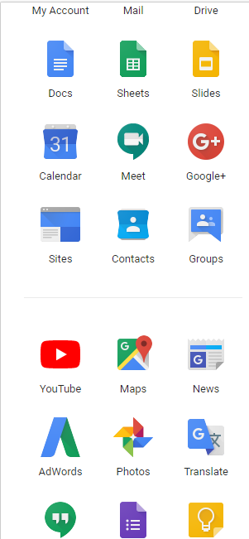

Next click on your profile picture in the upper right hand corner.
The below page pops open

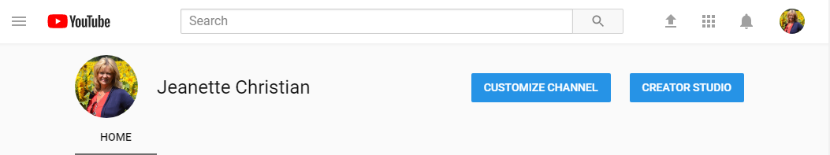

Click Creator Studio which takes you to your video manager.
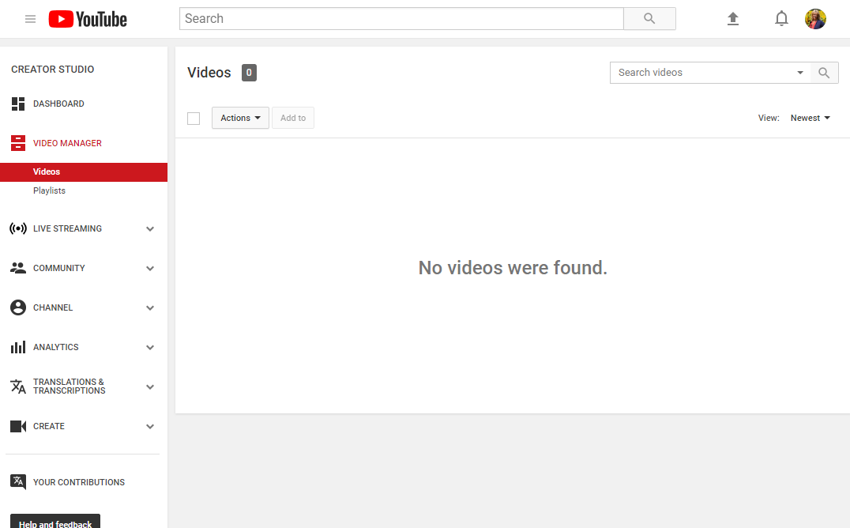

From Video Manager click LIVE STREAMING.
Under Live Streaming click Events
A new popup appears. Click new live event from these settings. 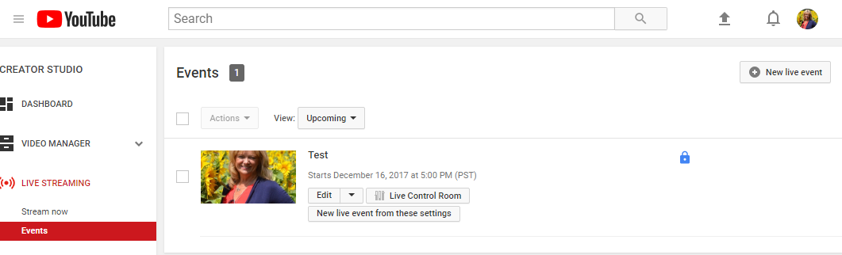
Complete the basic info tab below. Fill in title, description, private, public, et cetera. Be sure to set the start and end time and time zone.
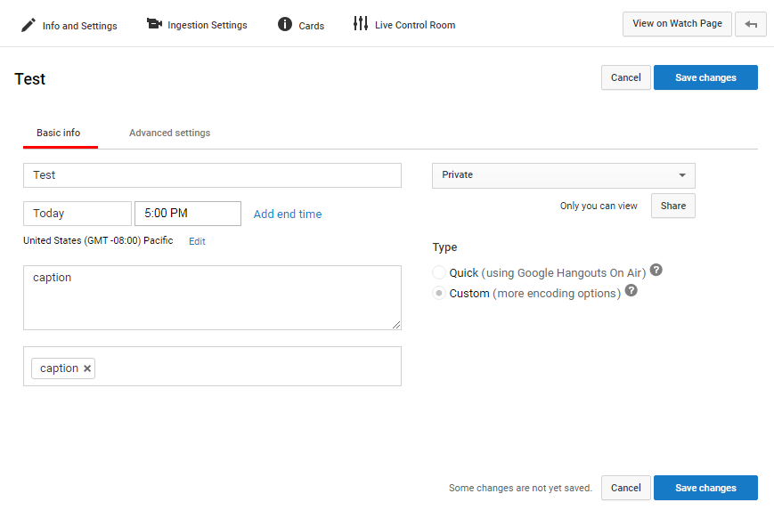
Click Save Changes.

On same page click Ingestion Settings.
After clicking ingestion settings the below pops up. Most options default to below and the links are self generated.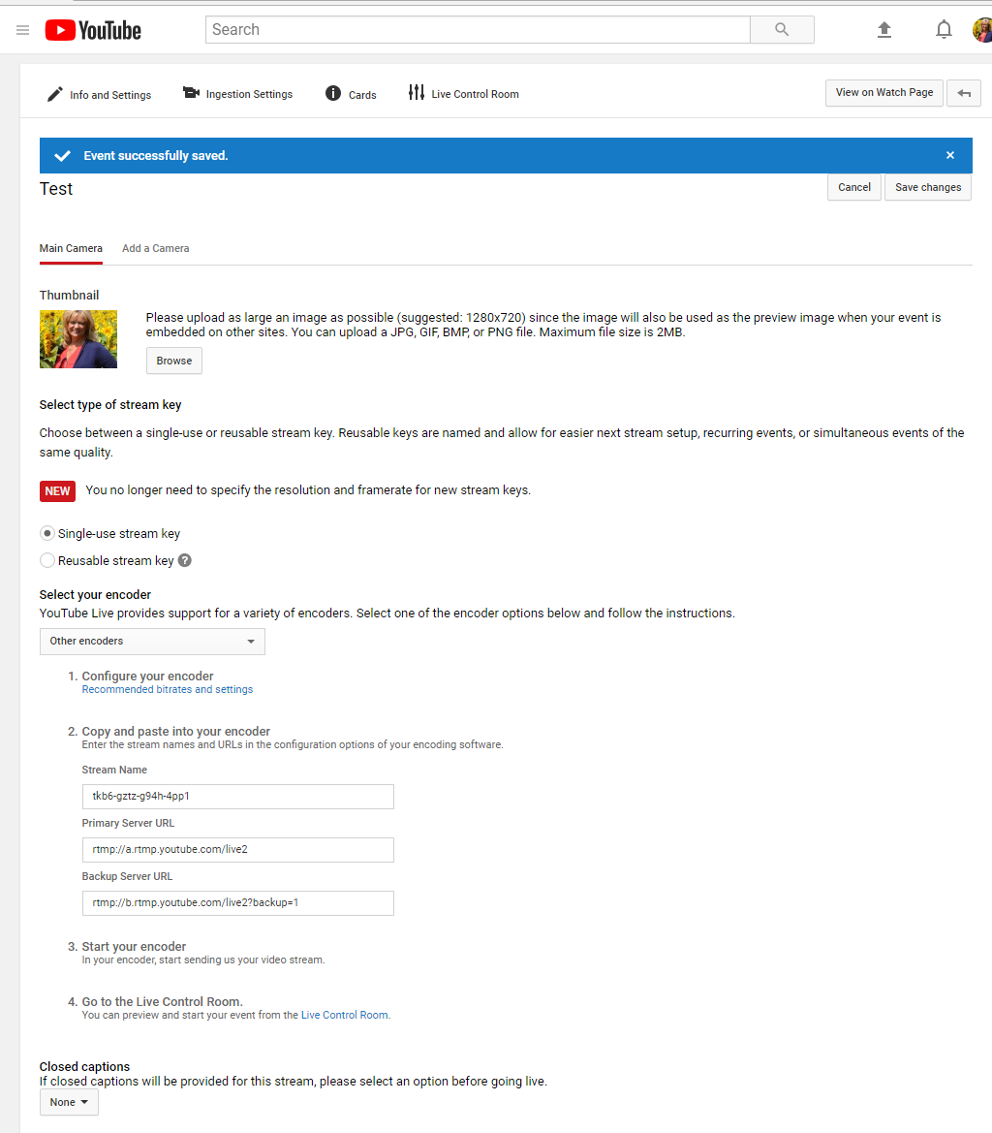
Last step, go to bottom of page Closed captions. Click the tick mark next to none and chose Post captions to URL.

Click SAVE. IMPORTANT ClICK SAVE

The Captions ingestion URL is what you email to the caption company to ingest into 1CapApp.
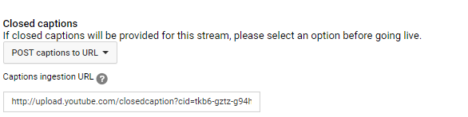

The Captions ingestion URL is ingested here on 1CapApp setup page.
