1CapApp Message Icon Instructions
Access 1CapApp by either going to www.1capapp.com or www.abccaption.com. There’s a 1CapApp tab at the top of the home page of ABCCaption.

Enter your user name and password.
Click on setup sessions
You will see your scheduled sessions. Next to the status bar, you will see a black message icon.

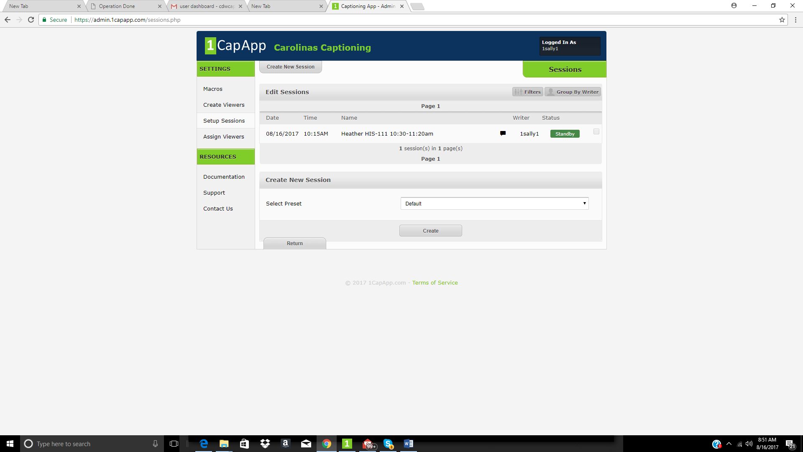
When you run your cursor over the black icon, it will turn red and pop up the information for your session. (scroll to next page for screen shot)


