- Left Click on the Start button
- Select Computer
- Double Click on Local Disk (C:)
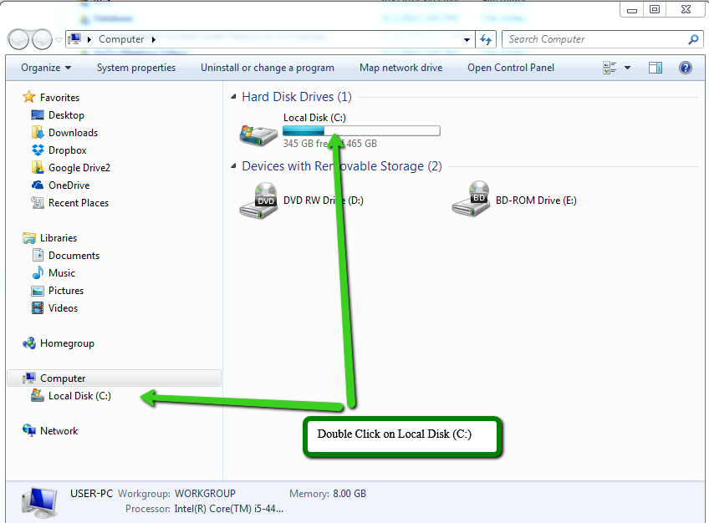

- Double Click on the Program Files (x86) folder
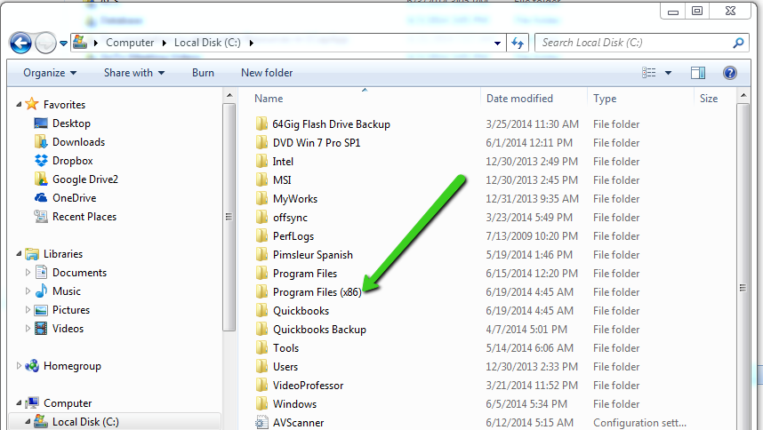

- Double Click on the 1Connect folder
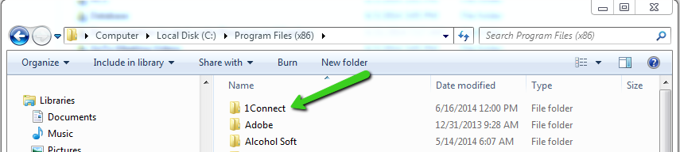

- Right Click on the 1Connect file
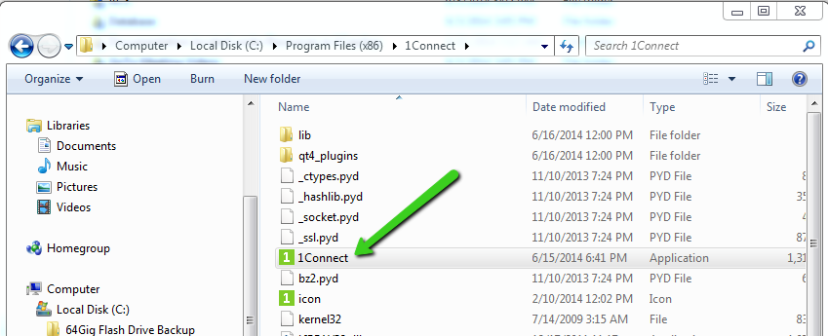

- Select Properties
- Left Click on the Compatibility tab
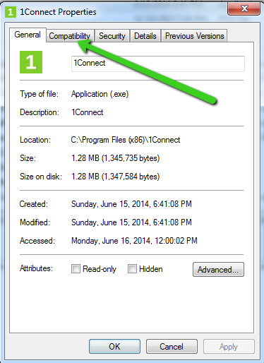

- About a 3rd of the way down on the page you will see:
Run this program in compatibility mode for:
Check this check box and select:
Windows XP (Service Pack 3) in the window below.
Click OK


