1Fuzion Download: http://1fuzion.1capapp.com/1Fuzion.exe
1Fuzion is for Onsite or Remote use.

Create a session on 1CapApp.
After you create a session, click on Hover On. It will change to Hover Off.
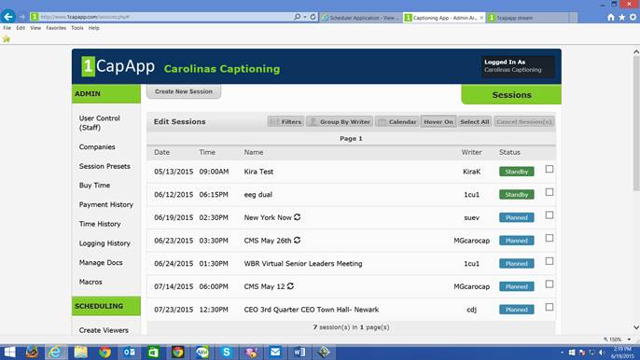

Then glide cursor over session line, right before where the writer is listed and get code number:
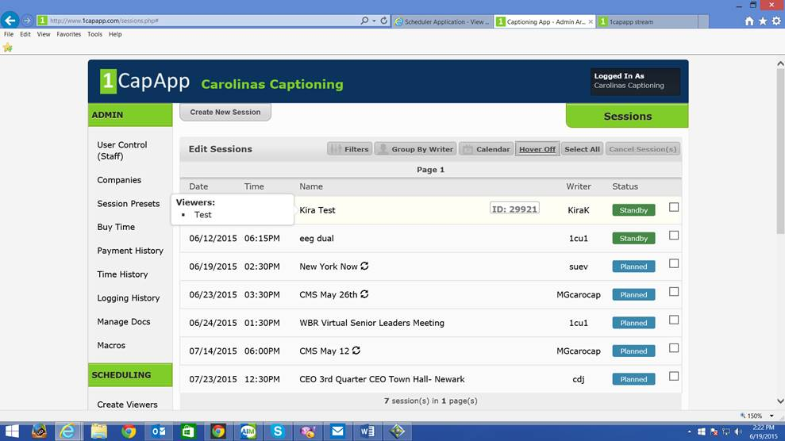

That code will be different for each session. For the example here, it’s 29921.

When you click on 1Fuzion icon on desktop, you will put this code into event ID.
Click Launch.
Then 1Fuzion will ask you for username and password. That will be the same username and password that you use to log into 1CapApp or any username and password for a viewer. If you schedule the session as hidden in 1CapApp, you will not need to bother with a username and password but will maintain the security level.

In 1Fuzion, fill out the fields, font size, colors, et cetera and then drag and drop the CC box where you would like it placed on the screen.

