Settings to Write into Collaborate with Eclipse CAT Software
If other CAT Software Jeanette could figure it out
Created Aug 2017

Step 1:
- Launch Eclipse
- Click ALT U and name the INI: Collaborate
- Click ALT U
- Realtime
- Output format: Keyboard macro
- Comm device: File sharing

Still in Output format: Checkmark Force Margins
- Left margin: 0
- Right Margin: 45
- Indentation: 0
- Click OK
- Click OK
- Click ALT U
- Click Save settings
- Make sure you named it: Collaborate so you remember when assigned to Collaborate platform you use this INI.

Now, start a realtime session and hit your steno keys to make sure you see yourself in your Eclipse Realtime File.

COLLABORATE PLATFORM
*Used to be Elluminate

Step 2:
Clear Cache (CTRL+F5) ** You should do this every morning regardless!

Customer will email a url link to the office. It will be similar to this:
- https://us.bbcollab.com/guest/38fa17de2baf4c2fb440205004b90698
- When you click on it to open up you will see Screen 1:

Screen 1
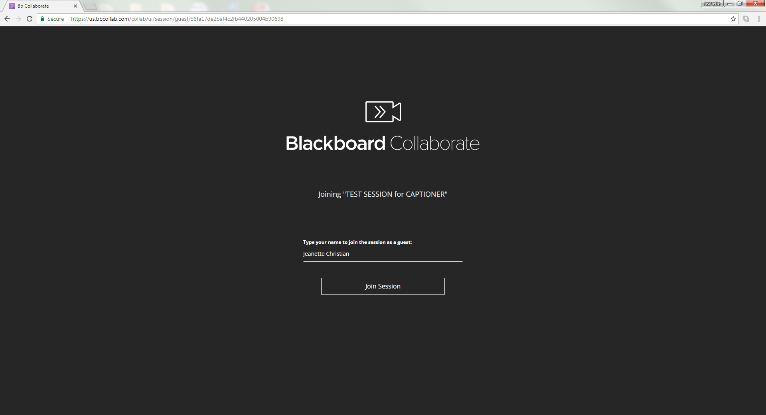

- Enter your name as CAPTIONER not your real name. I entered my real name for testing purposes only.
- Click: Join Session
- Screen 2 will open up

Screen 2
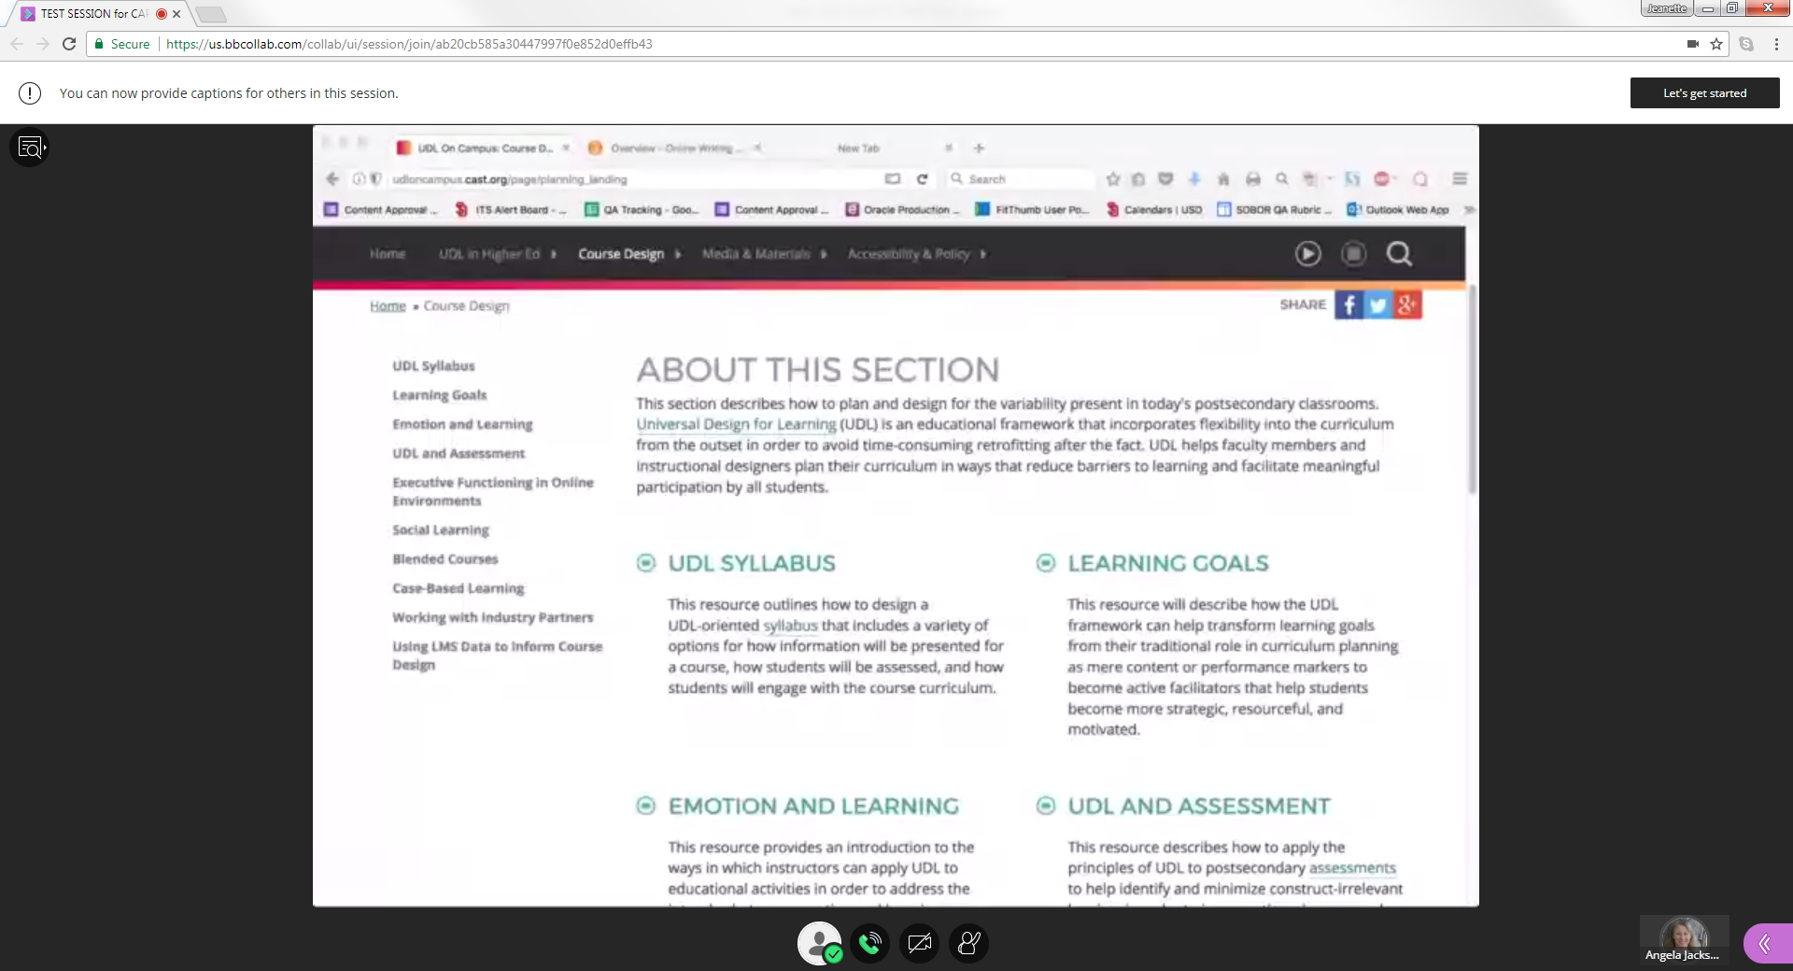

You will first:
- Unclick/unmute the mic and then click on the purple tab located here.
- Screen 3 below will open up.

Screen 3
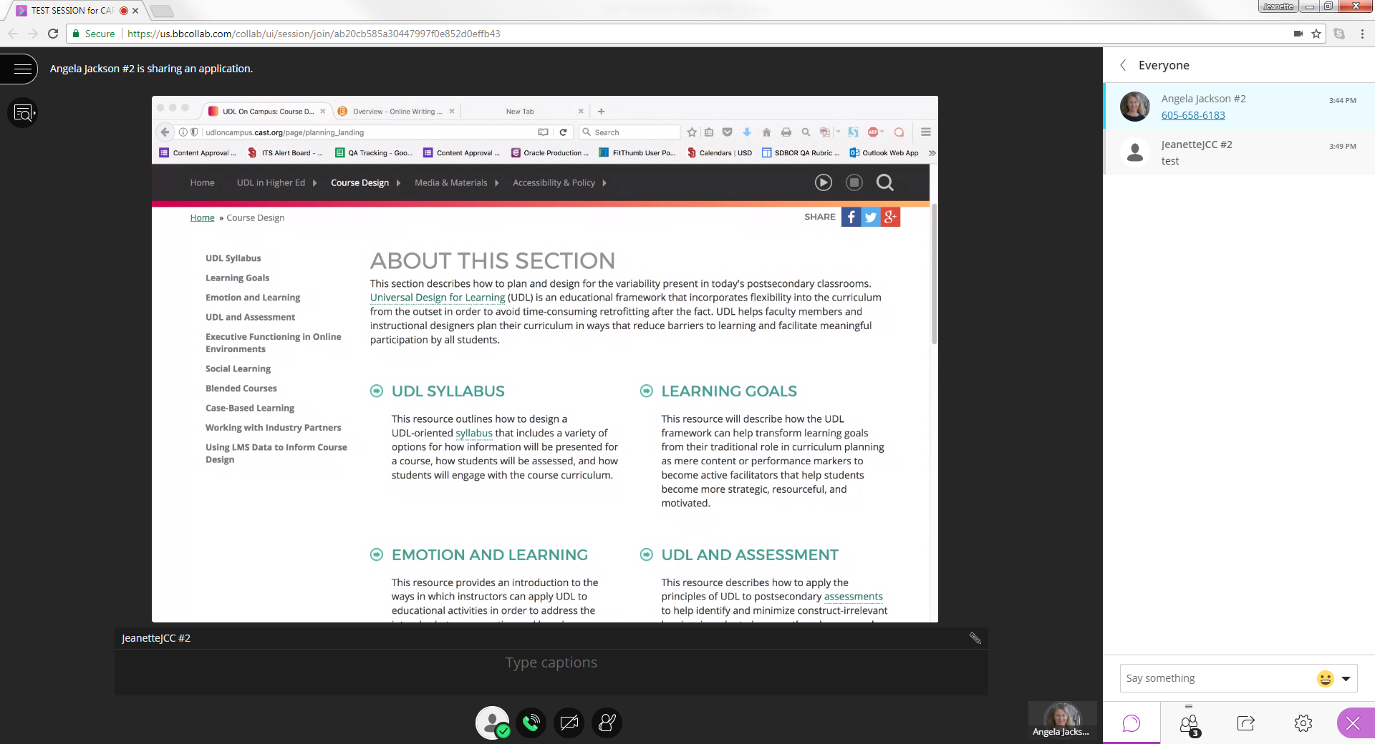

- Speak into your mic and ask the moderator to setup the closed caption feature.
- Make sure you then mute the mic or ask the moderator to mute your mic.
- Test and make sure you can still “hear” the moderator after you are muted.

Once the captioning feature is enabled Screen 4 will open up.
- You will know the captioning feature is enabled as a message pops up at the very top in the white banner - Very hard to see!
- Then you click: Let’s get started.
- Then Screen 5 will open up.

Screen 4
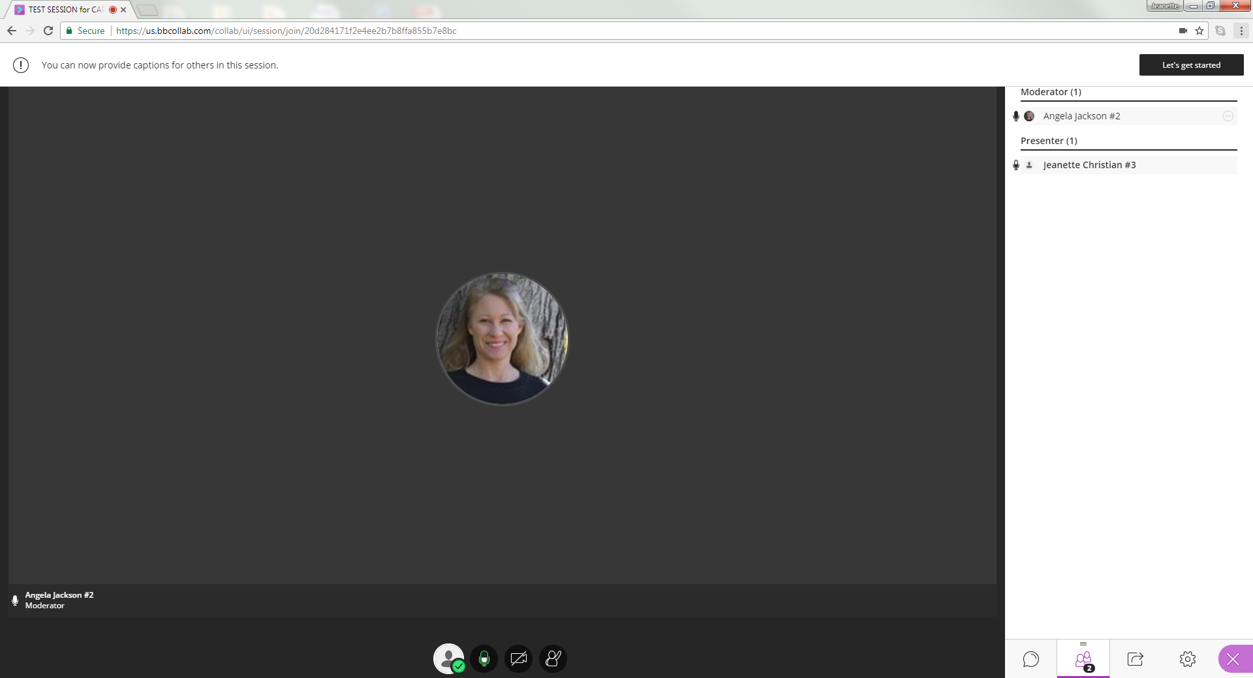

Screen 5
- You will see a caption box appear like TV. It is very dark and hard to see.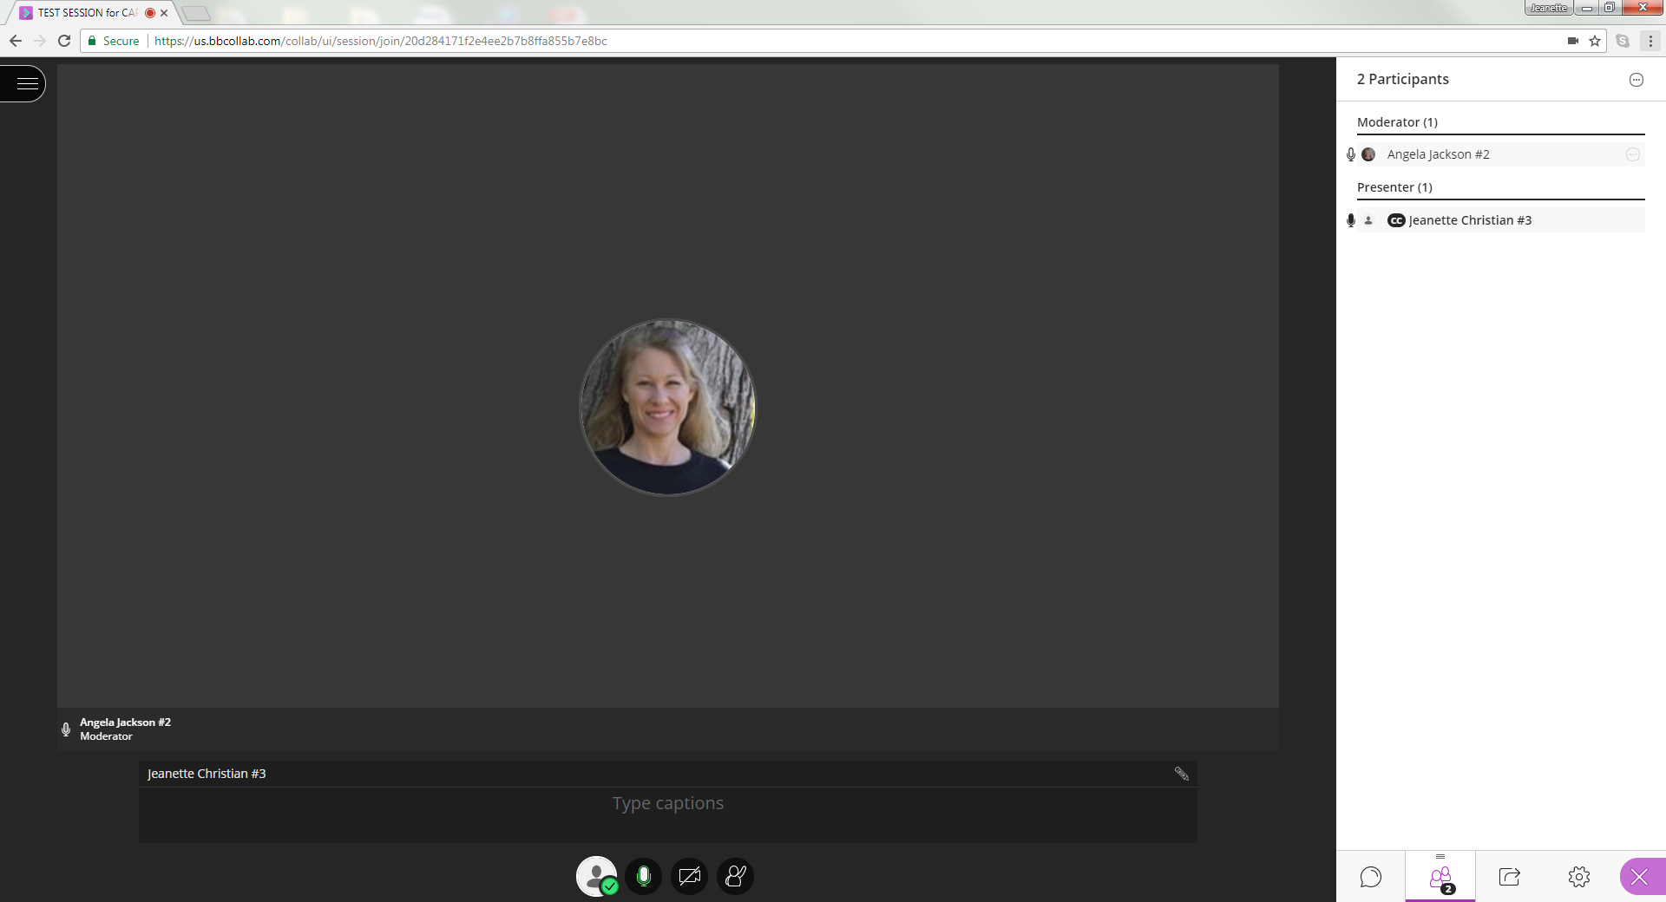

Screen 6
Next, place your cursor in the caption box and start hitting your steno keys.
- IMPORTANT: You MUST keep your cursor in the box or captions will NOT appear.
- If you have an extended screen on your computer LUCKY YOU. You can pull Collaborate over onto that extended screen and still see your CAT realtime file; if you don’t have an extended screen you will need to tile your CAT software and Collaborate but you must NEVER EVER move the cursor out of the Collaborate caption box or your captions will not appear.
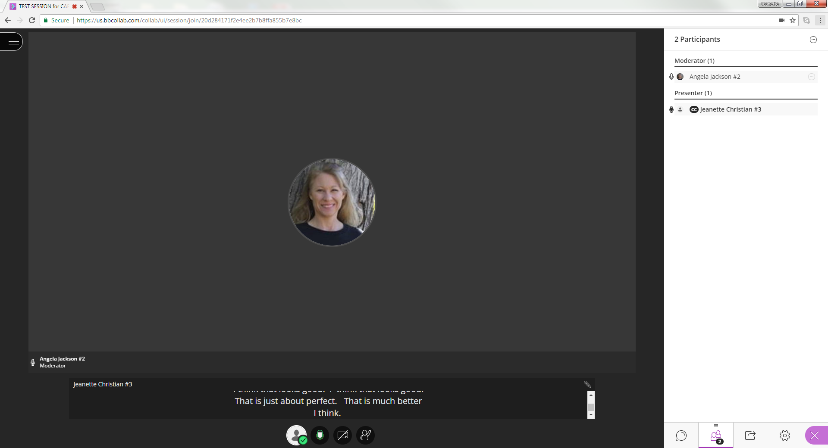

Happy Captioning!

Jeanette Christian
785 845-1230 (cell)

