Connecting and Writing to a Session

In this document we do not cover how to setup you CAT software. Please look for your CAT software setup in our documentation.

Download 1Connect and install
On main page, under “Softwares”, click on Download 1Connect. This is the page you see after logging in or you can click on the 1CapApp logo at the top left.

Follow the on screen instructions for installing the 1Connect. Install the software on the computer you will use when writing. At the end of the install, you will be asked to restart your computer. This is absolutely necessary.

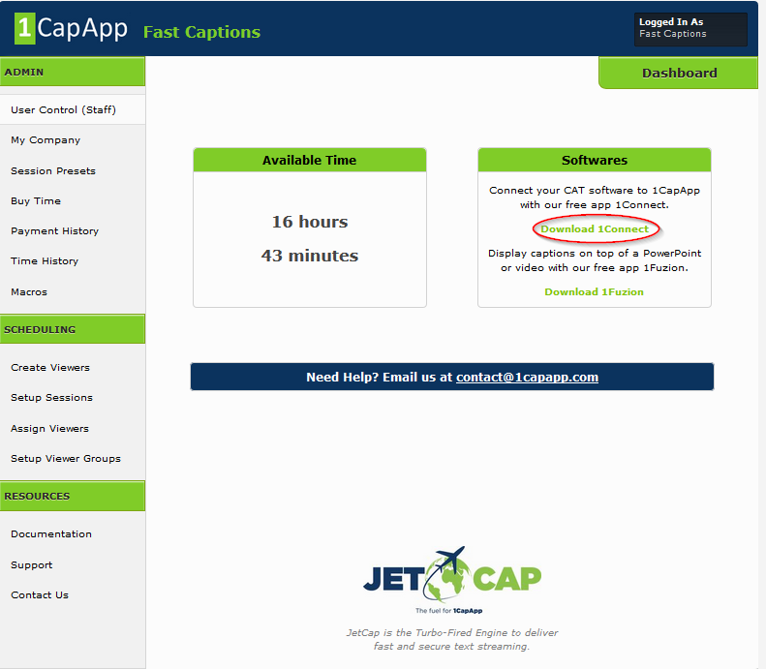

Ok Let’s get started:
Step 1

Schedule a 1CapApp Session
- Schedule a session in 1CapApp
- Make sure you assigned yourself as the writer in 1CapApp
- Start your 1CapApp session
Step 2

Make the connection with 1Connect

Double left click on the 1Connect Icon on your desktop. The screen shown on the left below will appear. Fill in the following information:

- Username: Enter your userid
- Password: Enter your Password
- Server: Select 1CapApp US
- Secure Connection: Check the check box (Must be checked !!!)
- Comm Device: Select Com, TCP/IP OR Interactive Stream
- For Com Port Input the same COM port in CAT Software
- For TCP/IP Server: Input 6969
- For Interactive Stream: Place your cursor in Text Box and start writing.
- Click Connect

- After you click connect the connection box changes and displays the connection information. Everything should turn green & you should see:
For Com Port: “Listening on COM port 45”
For TCP/IP: “Listening on port 6969”
For Interactive Stream you should see a text box. Put your cursor in it.

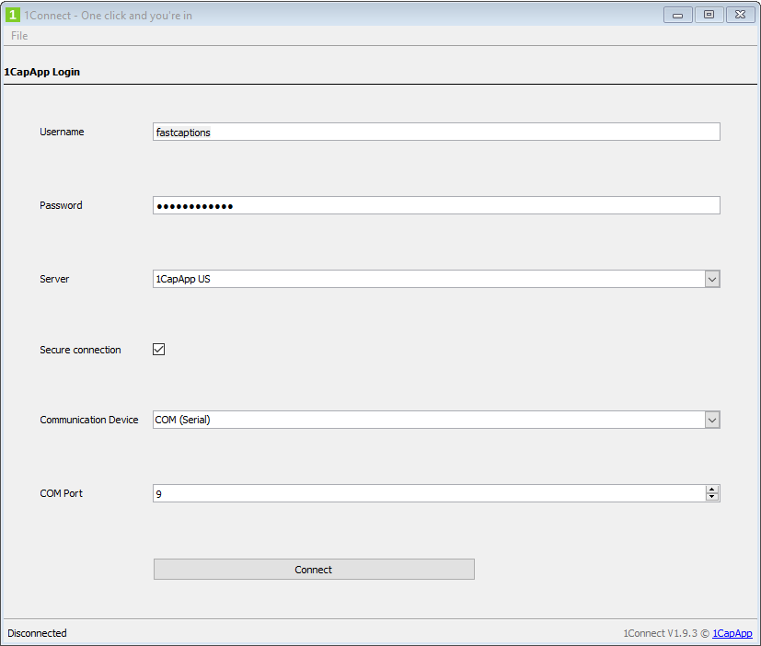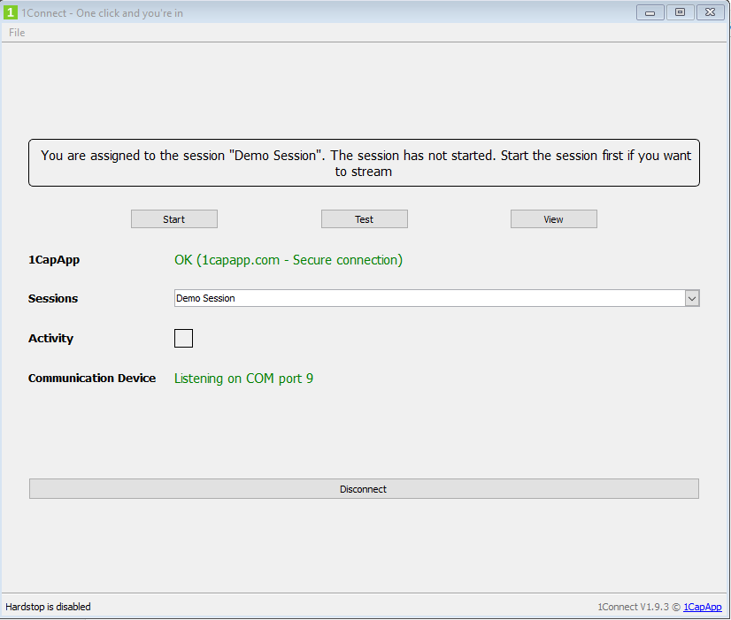

At the top, in the message box, you see a message saying you are assigned to the session: In this case I have assigned fastcaptions to the “Demo Session” session. At this point the session should have been started, but if you forget 1Connect will tell you. In this case you will want to disconnect and reconnect 1Connect after you have started the session. So the message at the top would say you are assigned to session “Demo Session”.

Step 3

Start you CAT Job & start writing

- Open up your CAT software and start a new job. This will be different for each CAT software. The main things to remember:
  - COM Port same as what is set in 1Connect.
  - COM Port is not the same as what is used by Streamtext.
  - Output is set to ANSI
  - Session has been started.
  - 1Connect is connected and says you are assigned to the session.
- Start a new job according to directions for your CAT software.
- Start writing

Step 4

View streaming text on Admin Dashboard
- Go to your Admin Dashboard: www.1capapp.com user/pass that you use to enter the dashboard of 1CapApp
- Select Setup Sessions
- Left click anywhere on your session
- Under actions tab click View

