Google Account Viewer

1CapApp allows you to input a viewer using the viewer’s Google account or Gmail ID.
When you input a new viewer select “Google”
Then input the viewer’s gmail email address in the “Email ID” field.
Click Save
You now have a viewer that can use their google account to log into the view page.

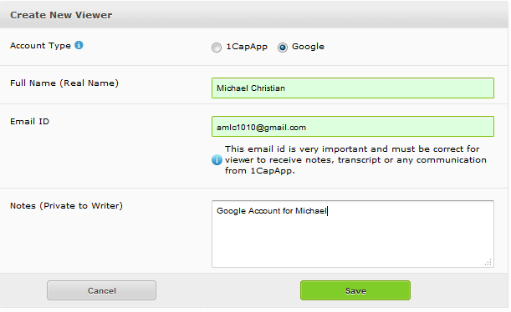

Log In using the Google Account: Next Page
Notice the Google Button underneath the Login Button.

You do not have to input a username and password, just click on the “Sign in with Google” button:

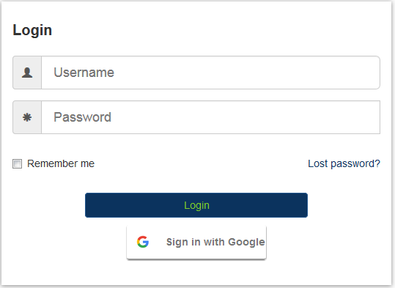

I am currently logged into my google account: michael@1capapp.com.
I did not define this Google account as a viewer for the Fast Captions company.
So I must log out of this Google account and log into the Google account that I defined as a viewer for Fast Captions: AMLC1010@gmail.com.

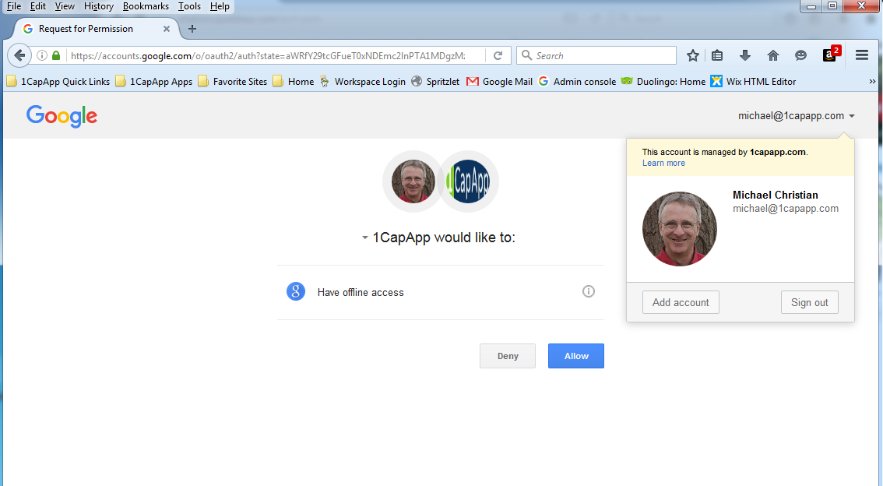

Sign in with the correct Google Account:

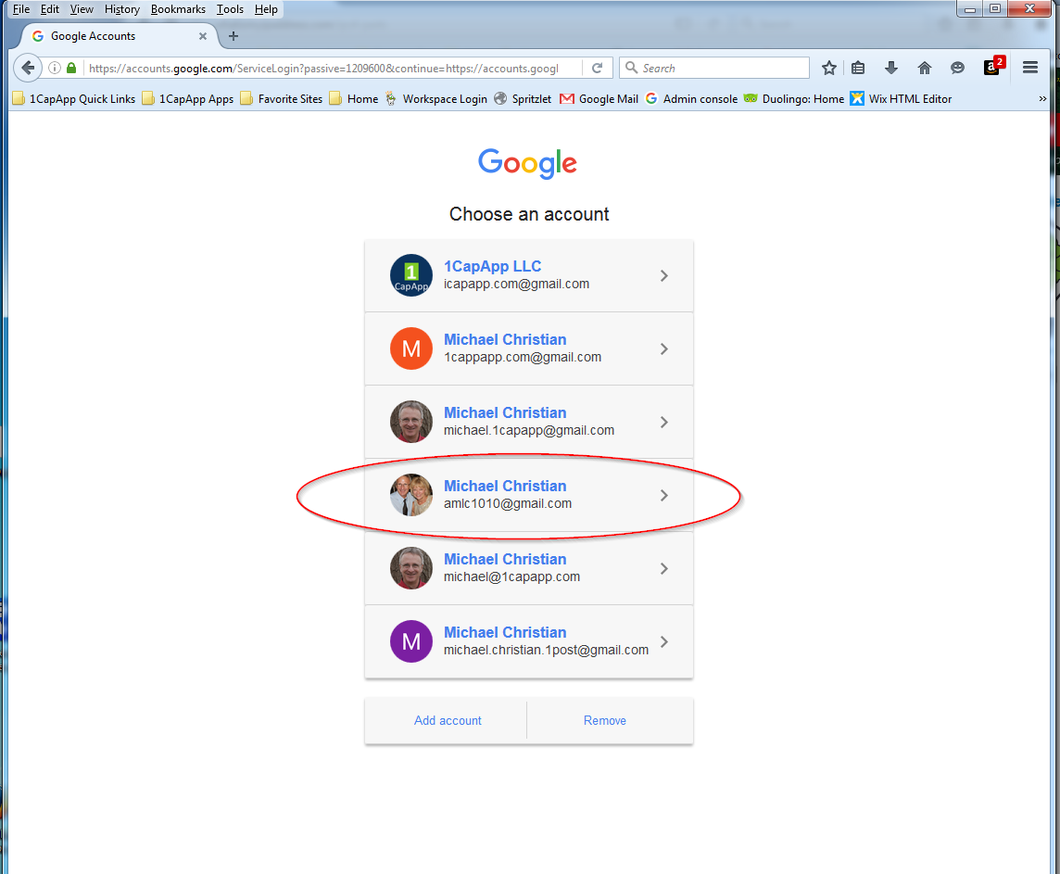

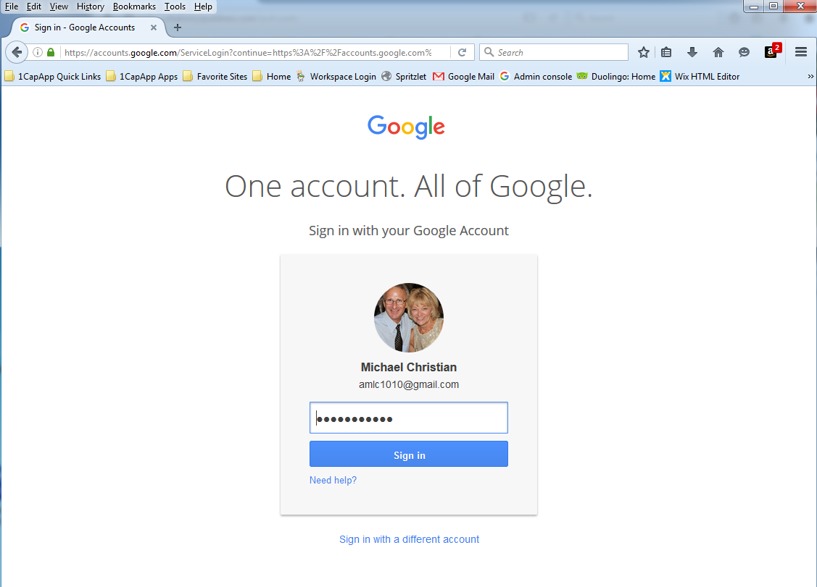

Now notice I am logged in with the correct Google account: amlc1010@gmail.com

Now, just click Allow, and you will be signed in as a viewer



