IP Restriction

The IP Restriction functionality allows you to input 1 or many IP addresses or ranges of IP address. When an IP address range is entered only IPs in that range are allowed access to the session’s view page.

You can setup a Preset:

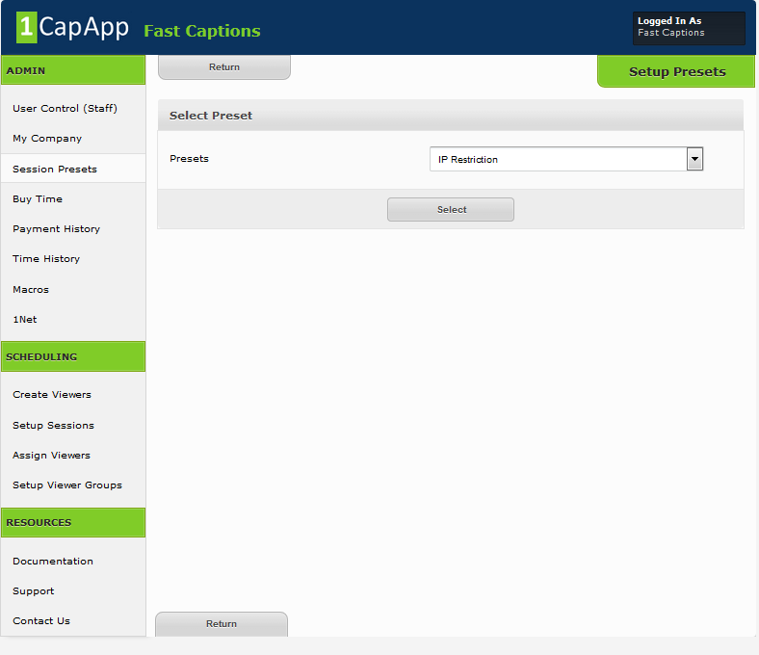

Click on the Connections IP Filter bar and the IP Restriction IP input screen appears.
Input an IP Range:

Each IP address is made up of 4 sections. Each section can have a value of 0 – 255.
The range that you can input is the last section.

The range will be the number in the last section.

So if my IP Address was 24.255.255.237, I could input a range that would include my IP address or a range that would include mine and many others:

A range that contains only 1 address:
24.255.255.237 – 24.255.255.237

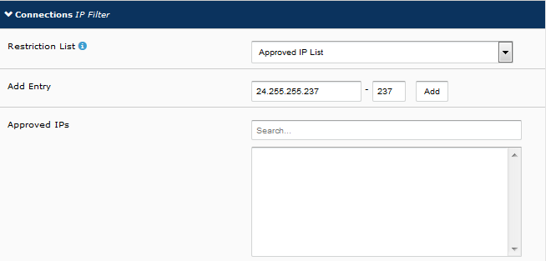

A Range that contains many addresses:
24.255.255.0 – 24.255.255.200

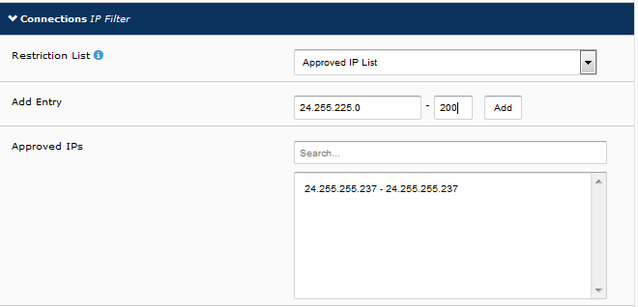

The following shows both IP ranges:

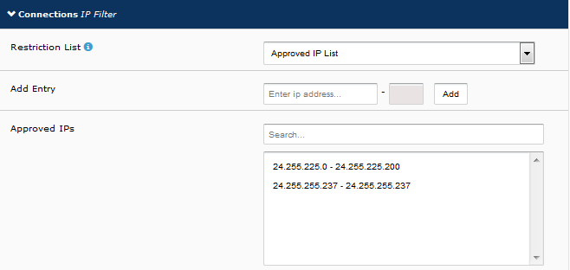

Currently you can only add and delete the IP address range.
To delete just click on the IP address range and save.

You also have the ability to “kick out” an IP address.
To do this you must have setup the restricted IP range when you scheduled your session:

From admin dashboard:
Click on Setup Session
Left click anywhere on your session
Under actions tab click Connection History
If you see an IP that should not be there, you can click to kick that person out.

