CSV Import of Schedules
We are working to provide our customers with a scheduling solution that is fully integrated with the 1Capapp platform. This means that you will only have to create one office schedule and then have the ability to push those schedules into 1CapApp. This is in a future release.

Currently 1CapApp allows you to automatically create 1CapApp sessions by importing schedules with a CSV file. You will save and Excel Spreadsheet of your schedules as a CSV file.
Your current office scheduler should have an export to excel, or you could be managing your schedule using Excel. In order to import the your schedules into 1Capapp automatically, you will need to create a CSV file with your schedules in the correct format.

The following is a step-by-step explanation of how this works.
A few important notes:
- You will have the ability to delete all sessions created from an import.
- Prepare your 1CapApp setup data properly prior to import. This includes your users and viewers. Your writers should be identified in the CSV file by their “Real Name” shown in the 1CapApp user record. The Viewers will have a viewer id when they are created. This id can be used in the CSV file to include multiple viewers for a schedule by separating the ids with a comma (be sure to format this column as text).
- We suggest that you import only a week at a time at most and to possibly manage your recurring events in 1CapApp and only import the non-recurring events.
- If you desire to import you recurring events they should be imported as individual sessions. This means that in your spreadsheet you will create one row for each recurring session. For instance if you have a recurring event at 9:00 AM on Mondays, Wednedays and Fridays, then in your spreadsheet you will have a row each week for this recurring event on Monday, Wednesday and Friday.
- You will also have the ability to delete all recurring sessions identified with the group id in the CSV file.
- An explanation of all the columns in the CSV Import Template is at the bottom of this document.
- The CSV Template is available in a separate document under documentation and on the Setup Sessions page under the CSV Import section.

Step by step instructions are on the next page.

Step by Step Instructions

- Create a spreadsheet of your live captioning events. Make your columns conform to the required CSV format. Screen shots of the CSV template are shown below with an explanation of each column.
- Once you have your CSV ready, go to the Setup Session page. At the bottom you will see CSV Import. You will see a Browse button.
- Click on the Browse button.
- A windows explorer pop-up screen will display. Navigate to your saved CSV file, select it and click ok.

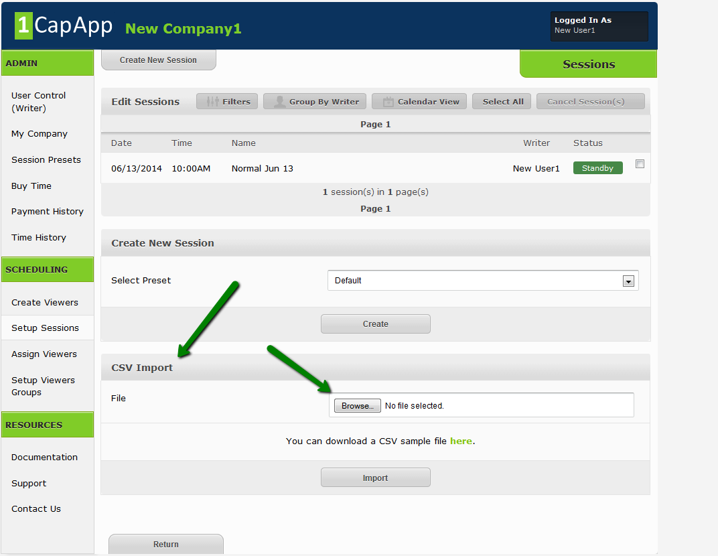

- You should see the file you select in the box next to the Browse button.
- Press the Import button
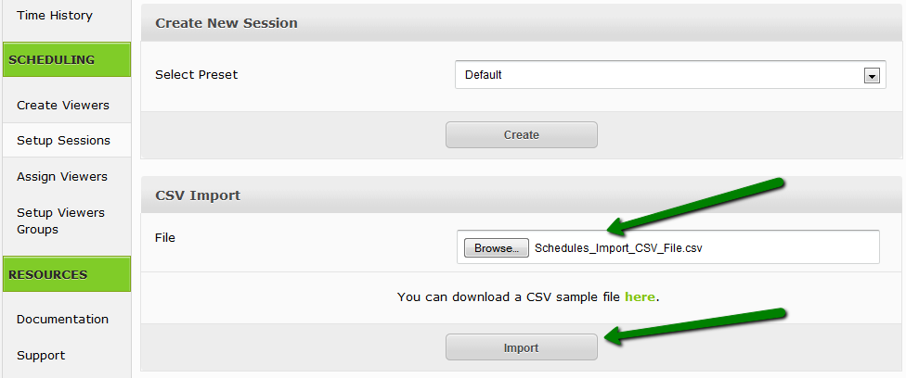
- Another window is displayed that describes the status of the import. It will show the status of each schedule imported. You can either edit the schedules here or return and go back to the Setup Sessions page and delete the whole import and make your changes in the spreadsheet. It’s your choice.
- When you are done click the “Confirm Import” button and all schedules will be imported and 1CapApp Sessions will be created for each schedule.
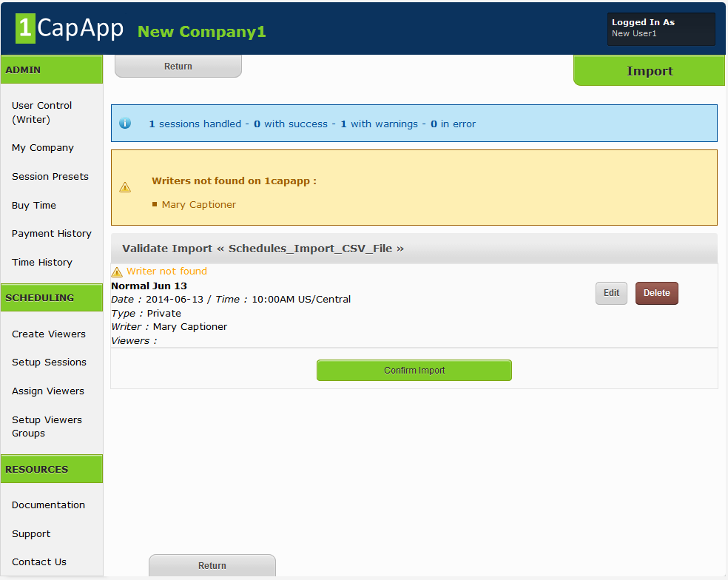

CSV File Column descriptions

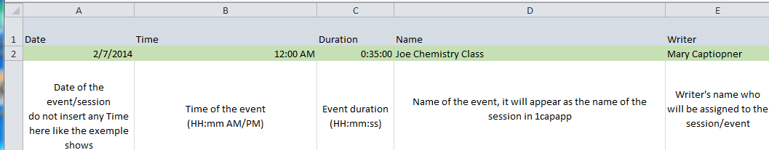

Column Name Format Description
***************** ***************** **************************************
Date Date Event Date. Must be in Date format
Time Time Event Time. Must be in Time format with AM/PM
Duration Time Event Duration in time format without AM/PM
Not currently used
Name Text Free Form Event Name. Freeform Text
Writer Text Free Form The Real Name of the Defined User in 1CapApp
Keep a list of writers in your spreadsheet that
Corresponds to 1CapApp users. Session will be
created with this assigned writer.

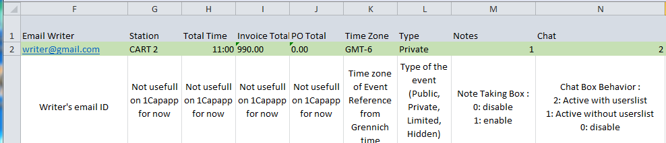
Column Name Format Description
***************** ***************** **************************************
Email Writer Text Email ID of the Writer
Total Time Time Not currently used by 1CapApp
Station Numeric Not currently used by 1CapApp
Invoice Total Currency Not currently used by 1CapApp
PO Total Currenty Not currently used by 1CapApp
Time Zone Text Time Zone in reference to Greenich Mean Time
Eastern = GMT-5
Central = GMT-6
Mountain = GMT-7
Pacific=GMT-8
London=GMT-0
Type Text Public, Private, Limited or Hidden
Must be spelled correctly as above
Notes Numeric 0 = Do not display Note Taking box on view page 1 = Display the Note Taking box on view page
Chat Numeric 0 = Do not display the chat box on view page
1 = Display chat box without the user list
2 = Display chat box with the user list

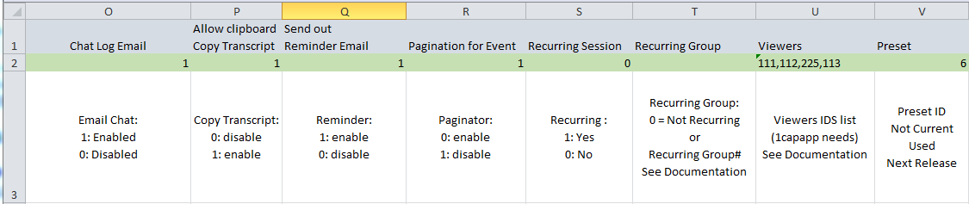
Column Name Format Description
***************** ***************** **************************************
Chat Log Email Numeric 1 = Allow viewer to email chat log 0 = Do not allow viewer to email chat log
Allow Clipboard
Copy Transcript Numeric 0 = Do not allow user to copy transcript 1 = Allow user to copy transcript
Send out Reminder Email Numeric 1 = Send out Reminder Email
0 = Do not send out reminder email
Pagination for Event Numeric 0 = Paginate event
1 = Do not paginate event
Recurring Numeric 0 = Not Recurring Event
1 = This is a Recurring Event
Group Numeric Unique ID for recurring Event
Supply a numeric id that will be unique for your recurring session. This way the system will be able to manage all recurring events at the same time with this unique ID. Suggestions are date and a sequence# For instance if today was May 1st 2014, a unique id could be 201405011. Date is 20140501 and the sequence number is 1. If you have more than 1 recurring event you are importing today just increment the sequence number to 2 and so forth.
Viewers Text Viewer id. You can get the viewer id from the
Create Viewer page in 1CapApp. If you have more one viewer separate the viewer ids with a comma.
Preset Numeric Not currently used. In the next release you will be
able to specify a preset here by using a preset id giving much more flexibility to the import function.
You can find the preset id on the create preset page.

