
Interactive Stream for Eclipse (Other CAT software would be similar settings)
Diagram No. 1:
CAT Output Format keyboard macro.
The others settings do not matter:

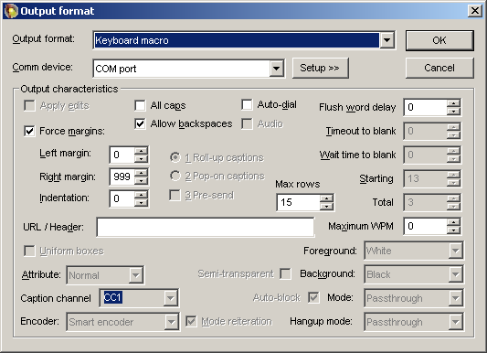
Schedule 1CapApp session
** Important!! The writer MUST log into the 1CapApp dashboard with the user and pass assigned to this session or you will not get the Interactive Stream Box.
Start session or let it start at scheduled time

Diagram No. 2:
Interactive Stream appears (see below)
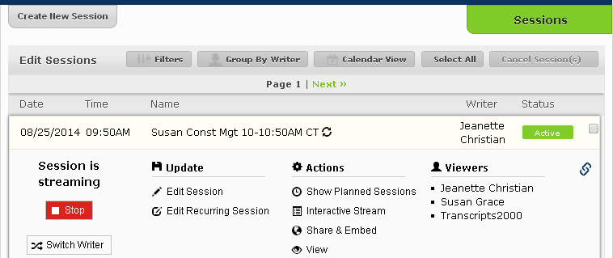
Start writing in realtime CAT file
Click Interactive Stream located above
Place your cursor in Interactive Stream and start writing
Your client gets your view link and logs in regular way: https://companyname.1capapp.com/login.php



