
www.1capapp.com
Phone: (855) 422-7277

CREATING A MACRO

When creating a macro in 1CapApp, you must first define the macro BEFORE scheduling a session.
If you are defining the speaker color change macro, you only need to enter a double chevron into the blank macro field. 1CapApp will do the rest.
For all other macros, please follow instructions below.
Go to the macro list found in the admin section of the writer’s dashboard. See below. Each writer/captioner must log into 1CapApp with
their assigned user name and password to create a macro. Again, this must be done BEFORE the session is scheduled.

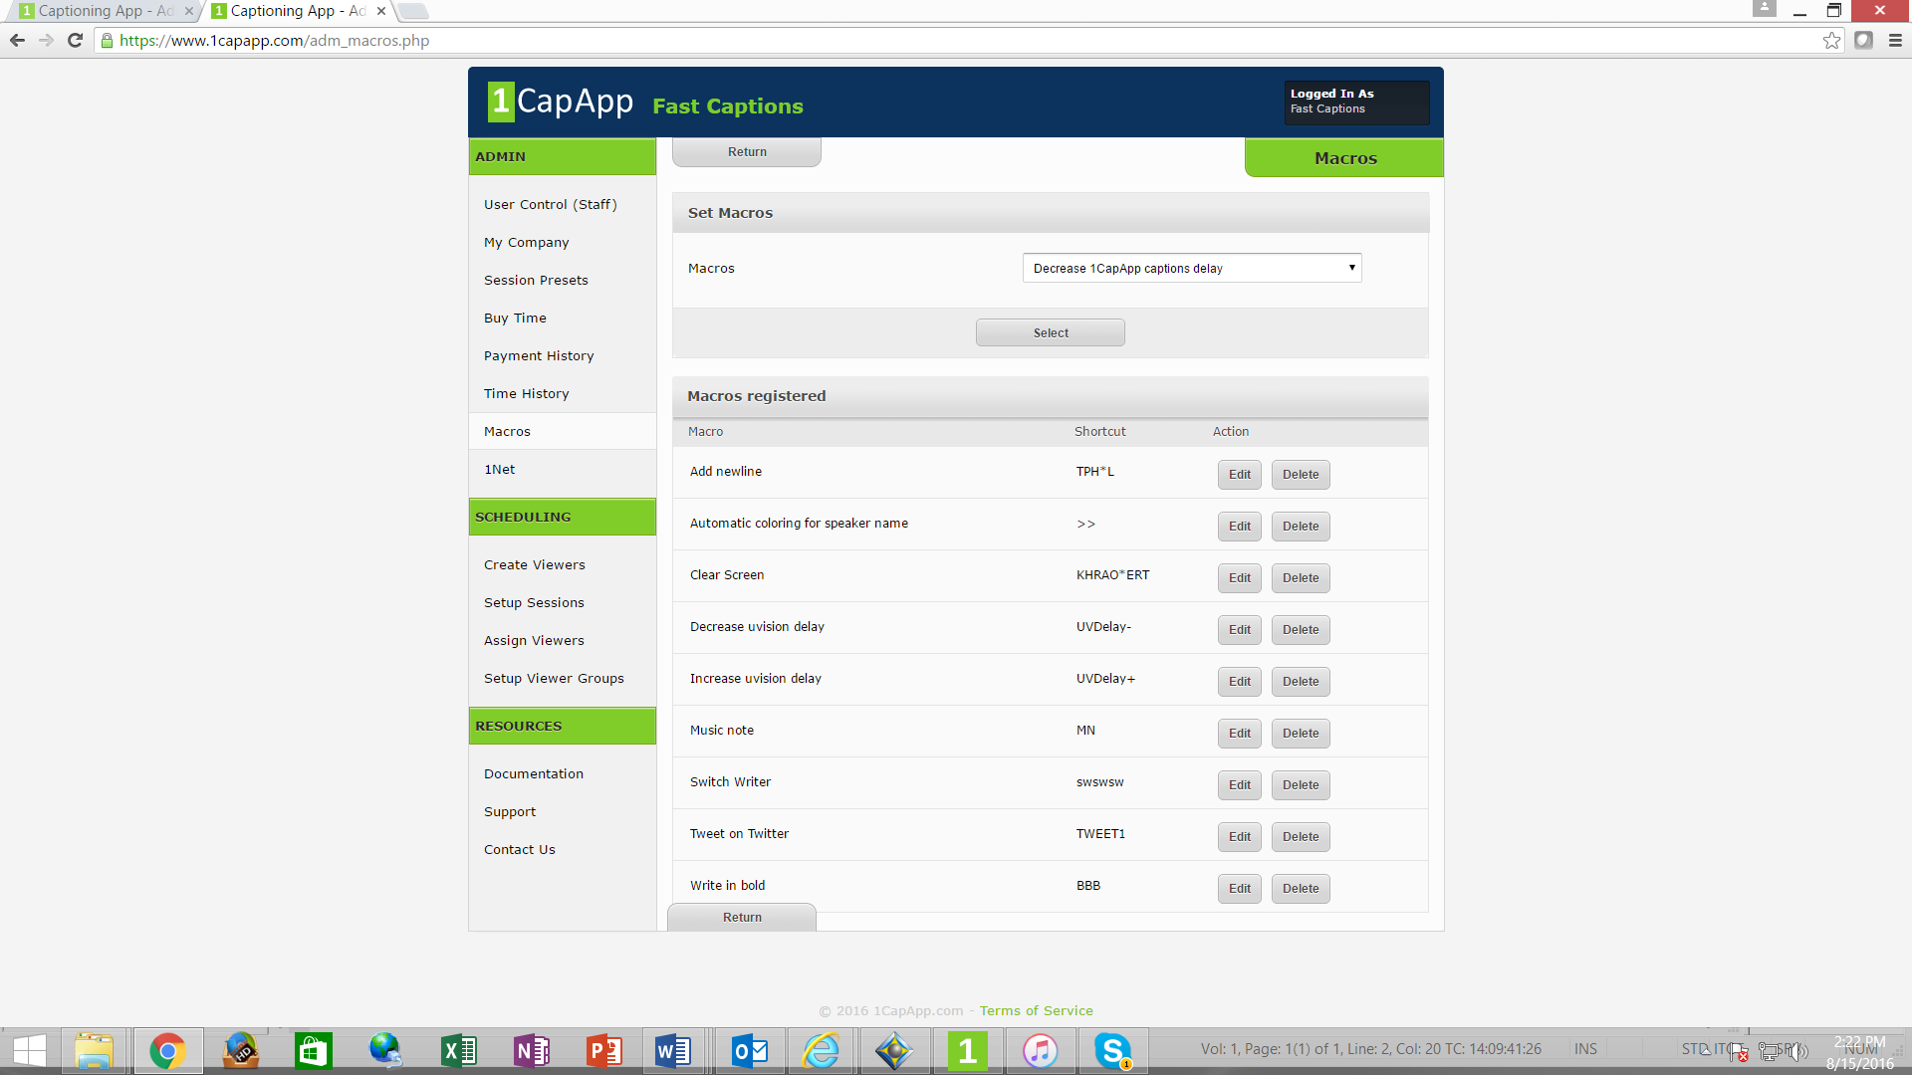

Once you have selected the macro you would like to create, you will enter the English definition of the steno or voice command you will assign to the macro.
If you want to clear screen and the steno stroke is CL*R and defined in English is CLR, then enter CLR (all caps) into the blank field to define the macro.
Use ALL CAPS in both your definitions for macro and in steno/voice definition. This is to prevent mixed case after punctuation.
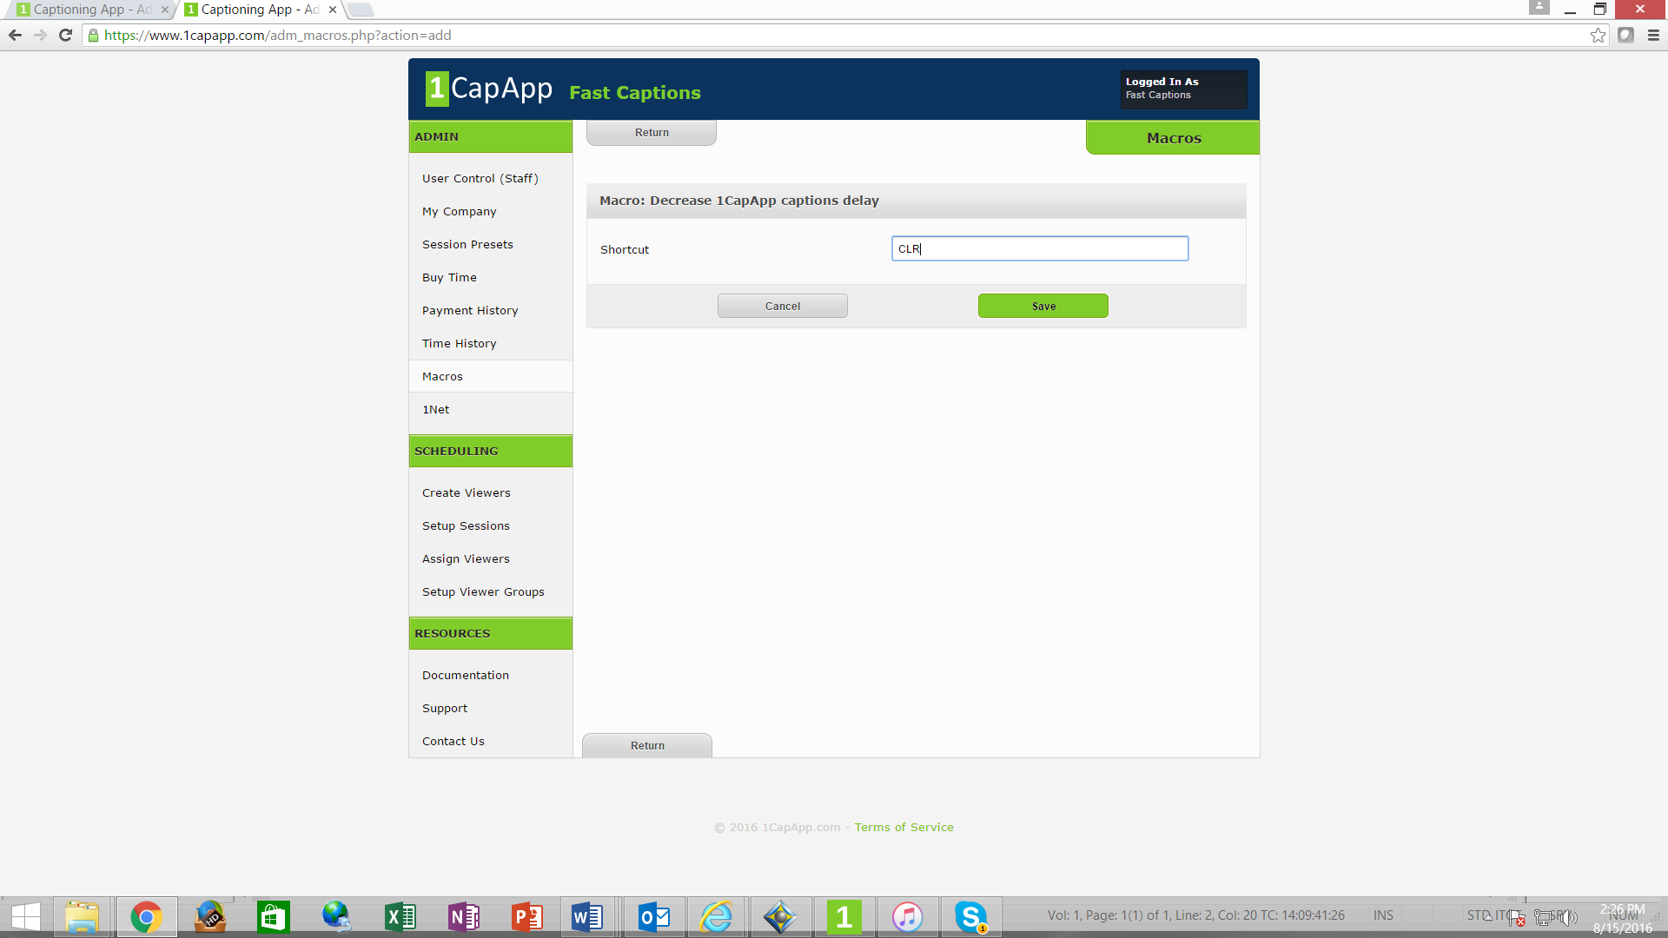

Once you have defined in both 1CapApp and in your software, schedule your session.

