
www.1capapp.com
Phone: (855) 422-7277

1CapApp & Feeding in your Script to your CAT software

The goal here is to cause a new line feed after each period in your script file that you will F12 during your captioning event. For some reason your CAT software swallows up the Carriage Return Line Feed in the script file and does not send a new line.

1CapApp has solved this problem by allowing you to define a macro or text string that it will recognize and convert into a new line. Your script file will be sending the 1CapApp streaming server a period followed by a macro. The text string “TPH*L” is only being used as an example. You can define any text string as your macro that you want. 1CapApp will see this text string macro and replace it with a new line.

You will edit your text file in Word or Notepad++ executing multiple search and Replace All functions changing some paragraph marks & some special characters to be followed by the New Line Macro text and a Paragraph Mark. All paragraph marks will be preceded by the New Line Macro text.

Thus you will need to display Paragraph Marks: ¶. By having the paragraph marks displayed, you will easily be able to see where you need to make your changes.

Important: You can choose any macro you want. TPH*L is for explanation purposes only. The macro TPH*L WILL be displayed in your CAT realtime file but will NOT be displayed on your 1CapApp screen.

If you don’t already know how to do this instructions follow. The instructions look long and complicated, but it really is a simple process. Once you have done it once it will be easy and intuitive.

The following is what you need to do:
Steps for Using Microsoft Word: (If you don’t have Microsoft Word scroll down to Notepad++
- Open Microsoft Word
- If you have a version that displays the Paragraph Mark at the top of the Home tab about in the middle, then this is a toggle on/off for displaying the Paragraph Marks. Just click this icon for toggling on and off the display of paragraph marks. Thus, you do not need to do the File/Options/Display and check the Paragraph Marks.

- Otherwise: Select File
- Select Options
- Select Display
- Check the checkbox for Paragraph Marks
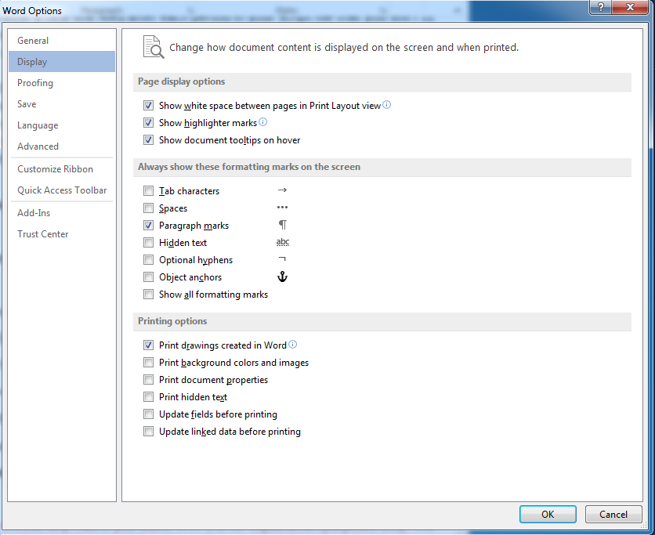
- Click OK

No Paragraph Marks displayed


Paragraph Marks displayed:


- Open the script you want to modify.
- Type Ctrl+h (press on the control key while at the same time press h)
- This should bring up the advanced search and replace screen (See next page)
First let’s work on the Paragraph Marks
- Put your cursor in the “Find what” box
- In the search and replace window you will see the Special box at the bottom. To search for a Paragraph Mark click on the “Special” button and select “Paragraph Mark”. This will put a “^p” in the search box.
- In the Find What Box Type 4 spaces and then push the Special at the bottom & select Paragraph Mark. This will put a ^p in the “Find what” box. So you should have 4 spaces followed by ^p in the “Find what” box.
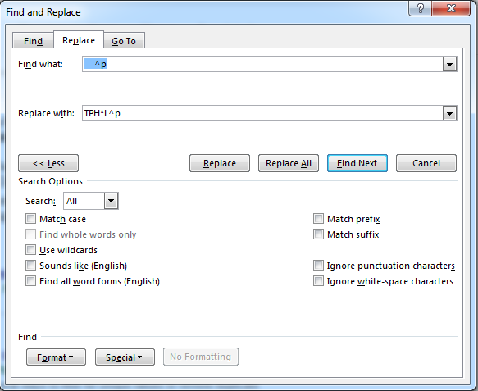
- In the Replace with: box type “TPH*L^p:”
- Push the Replace All button
- Repeat this process deleting 1 space each time: See below ( Do not include the “s )
Find What: “ ^p” Replace With: “TPH*L^p”
Find What: “ ^p” Replace With: “TPH*L^p”
Find What: “ ^p” Replace With: “TPH*L^p”
Find What: “ ^p” Replace With: “TPH*L^p”
Find What: “^p” Replace With: “TPH*L^p”

Do something similar for all special characters you want to follow with a Paragraph Mark, but this time you will add the Paragraph Mark
This is important: Stop after you have done it with 1 space after the special character. It should be taken care of in the first search and replace. Some of the special characters already have a paragraph mark after it. This would have been handled in the first search and replace we did.
Some examples follow

Special Character Period “.” ( Do not include the “s )

Find What: “. ” Replace With: “.TPH*L^p”
Find What: “. ” Replace With: “.TPH*L^p”
Find What: “. ” Replace With: “.TPH*L^p”
Find What: “. ” Replace With: “.TPH*L^p”

Special Character Question Mark “?”

Find What: “? ” Replace With: “?TPH*L^p”
Find What: “?” Replace With: “?TPH*L^p”
Find What: “? ” Replace With: “?TPH*L^p”
Find What: “? ” Replace With: “?TPH*L^p”

Special Character Colon “?”

Find What: “: ” Replace With: “:TPH*L^p”
Find What: “:” Replace With: “:TPH*L^p”
Find What: “: ” Replace With: “:TPH*L^p”
Find What: “: ” Replace With: “:TPH*L^p”

Important: You can choose any macro you want. TPH*L is for explanation purposes only. The macro TPH*L WILL be displayed in your CAT realtime file but will NOT be displayed on your 1CapApp screen.

Save the file as a text file and you are ready to go.

Instrucstions for using Notepad++
- Download and install Notepad ++ (Free text file editor that does much more than Notepad) http://notepad-plus-plus.org/
- Save your script file as a text file. Save As Plain Text, file extension .txt
- Open Notepad ++
- Copy and paste the text file into Notepad ++ (CTRL A to copy / CTRL V to paste)
- Click on the View menu item at the top
- Select Show Symbol / Show All Characters & Word Wrap

Important: You can choose any macro you want. TPH*L is for explanation purposes only. The macro TPH*L WILL be displayed in your CAT realtime file but will NOT be displayed on your 1CapApp screen.

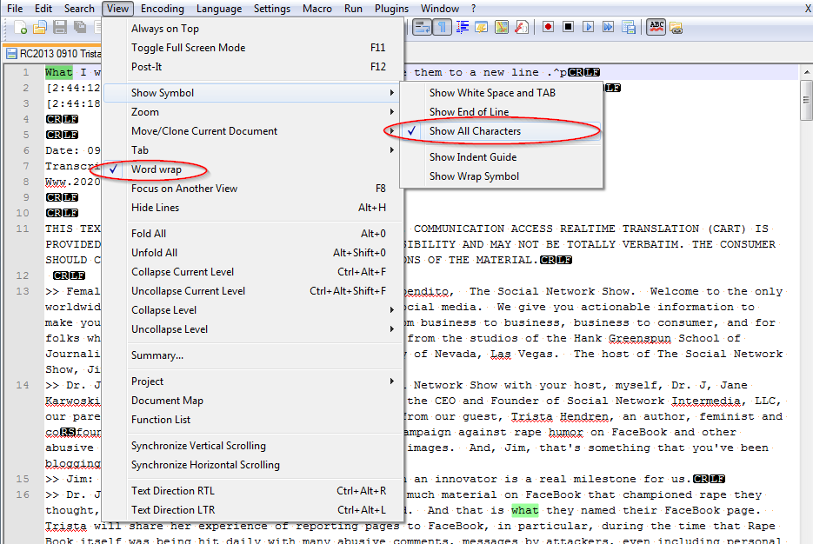

- Next start replacing periods with your 1CapApp macro: Example macro is “TPH*L”
  - CTRL F or Select Search in tool bar / Find /Replace and select Extended at bottom left and checkmark in wrap around. (See screen shot below)
  - Replace with: “. \r\n” with: “.TPH*L” (Push button for Replace All)
The CRLF that is highlighted in Black with White letters are non-displayed Carriage Return Line Feed characters. When searching for these character use “Extended” search mode and they are represented as \r\n.

IMPORTANT: The order how you add the Carriage Return and Line Feed after the periods is important.

First search for periods with a Carriage Return and Line Feed after the period. The next two exercises may seem redundant but they are not! Please follow instructions.

Start with a period & 4 spaces and Carriage Return and Line Feed. Then Period & 3 spaces, Period & 2 spaces; and, finally, a period, no space and Carriage Return and Line Feed. Do ALL of these:
“. \r\n” Replace with: ".TPH*L\r\n"
“. \r\n” Replace with: ".TPH*L\r\n"
“. \r\n” Replace with: ".TPH*L\r\n"
“. \r\n” Replace with: ".TPH*L\r\n"
“.\r\n” Replace with: ".TPH*L\r\n"
“.” Replace with: “.TPH*L\r\n
Yes do the one with no space.

Next Search for only a period with 4 spaces after it….then 3 spaces, 2, and 1.

“. ” Replace with: ".TPH*L\r\n"
“. ” Replace with: ".TPH*L\r\n"
“. ” Replace with: ".TPH*L\r\n"
“. ” Replace with: ".TPH*L\r\n"
Important: Do not do the one with no space

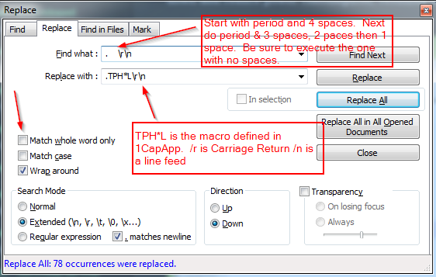

Look at your script you are creating. If script has some lines indented and not flushed to the left line, you can do this:
1 CTRL A to highlight all of text
2. Click Edit in Notepad++
2. Click Indent
3. Click Decrease Line Indent (Shift/Tab)

Important: You can choose any macro you want. TPH*L is for explanation purposes only. The macro TPH*L WILL be displayed in your CAT realtime file but will NOT be displayed on your 1CapApp screen.

Before:
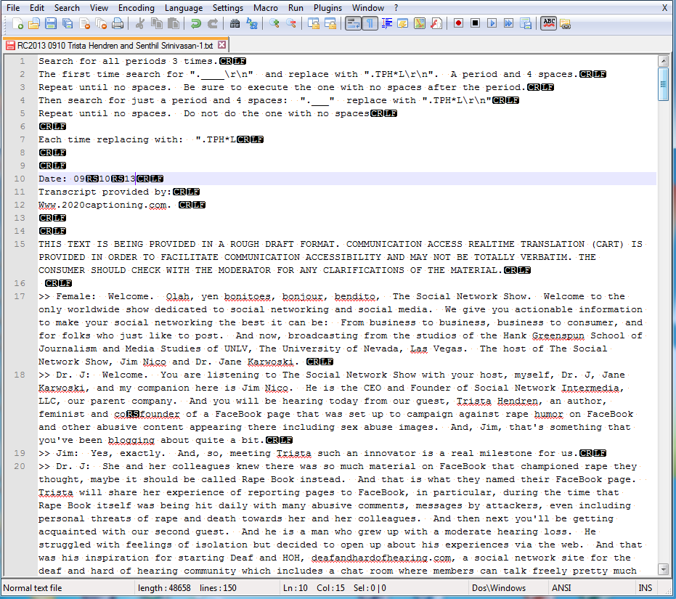

After:
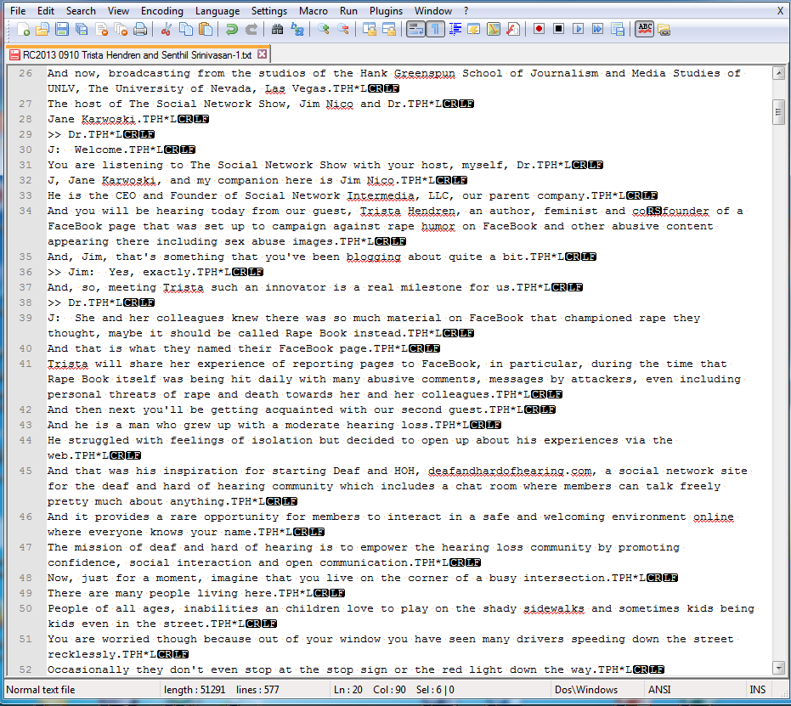
Important: You can choose any macro you want. TPH*L is for explanation purposes only. The macro TPH*L WILL be displayed in your CAT realtime file but will NOT be displayed on your 1CapApp screen.

1CapApp Macro Setup:
- Select Macros menu item on the left
- Then select Add newline macro

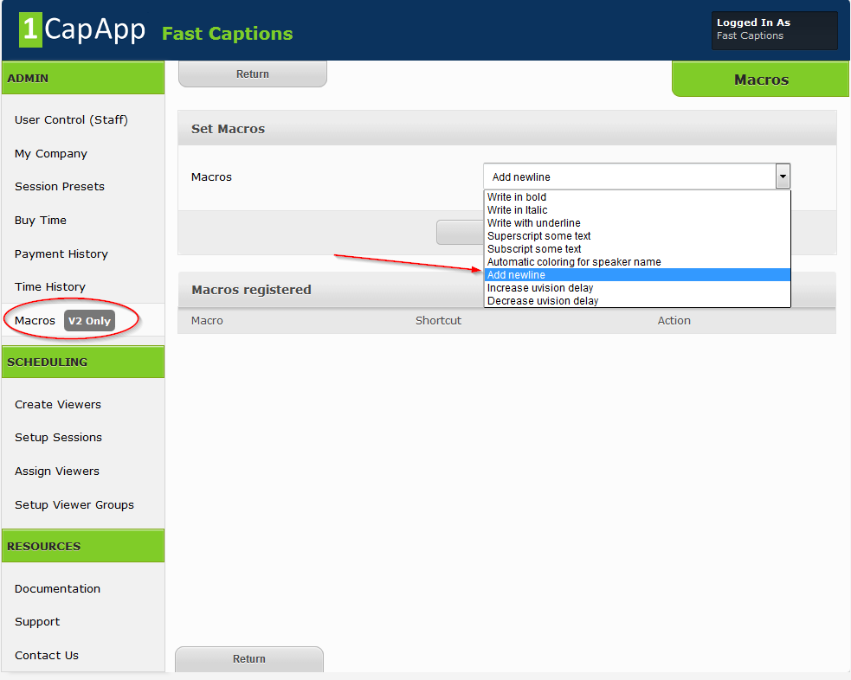

Press Select

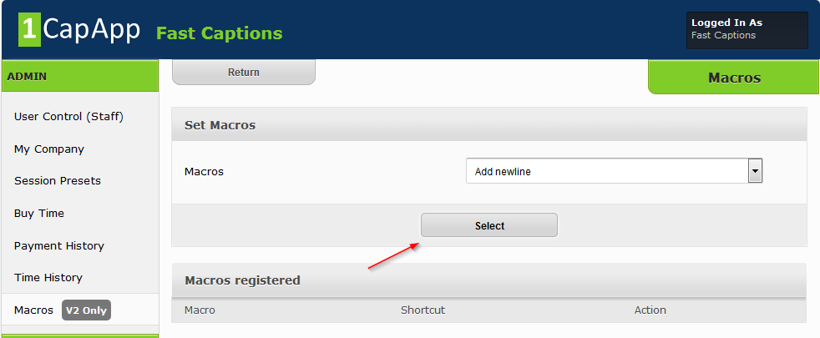

Next type in the macro you used when you were editing your script/text file. For our example we used: TPH*L
Press Save

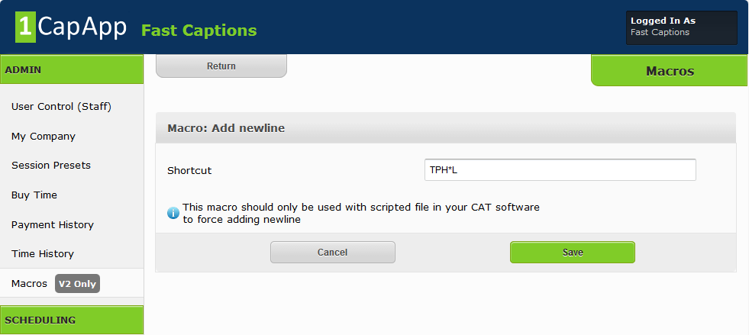

IMPORTANT: You may want to scan your script for Dr. or C.I.A. any acronyms with periods as the above exercise we just did will put in a new line after ALL periods.

IMPORTANT: You will notice the macro (steno) IS inserted into your CAT realtime file. If your client requires a rough draft transcript after the fact you will do this to remove the macro:
1: Save your CAT file as a text file or RTF.
2: CTRL F
3: Search for your macro (TPH*L) and replace with a blank space.
4: Save

Important: You can choose any macro you want. TPH*L is for explanation purposes only. The macro TPH*L WILL be displayed in your CAT realtime file but will NOT be displayed on your 1CapApp screen.

