Boxes can be resized:
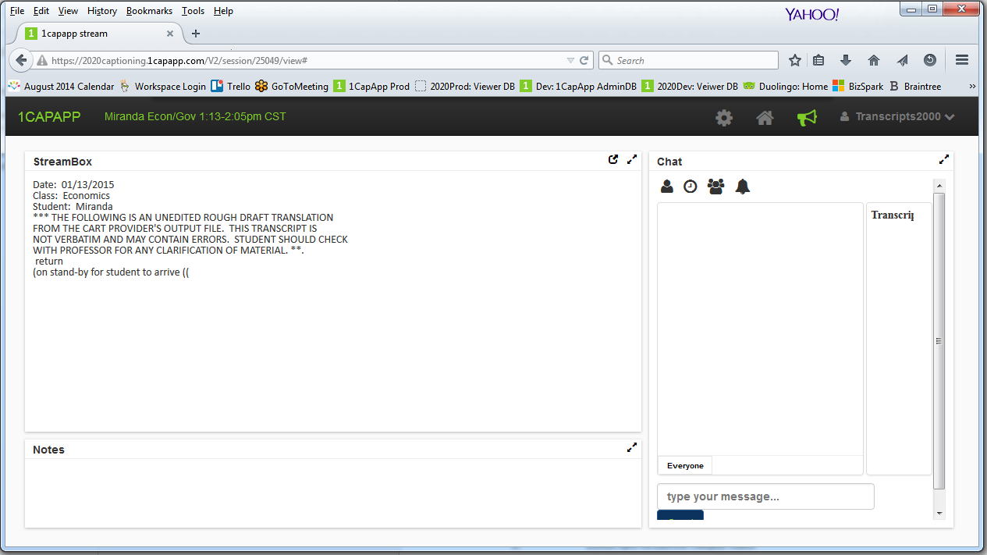

Settings can be adjusted here: Font, Colors, Lines per page, Line spacing.
Each Widget can be customized: Stream, Notes & Chat boxes.

Main Settings control all widgets / boxes at the same time plus all the other general settings.

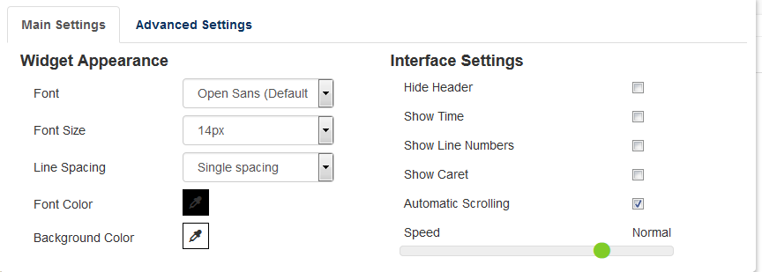
Advanced Settings Control each widget/box individually. Click on Stream Box, Notes Box or Chat Box and you can set the Font, Font Size, Line Spacing, Font Color and Background color for each.
I currently have Chat Box selected:

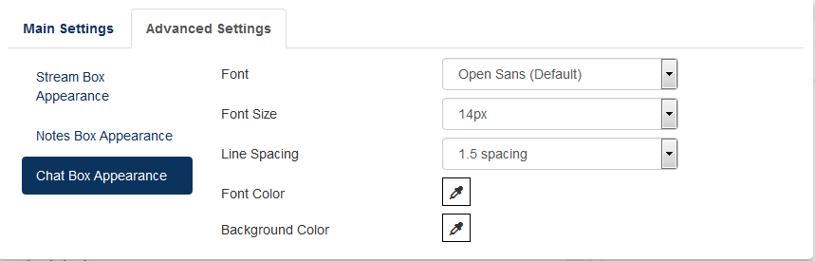

You can open the Stream Box in new window by clicking on this icon:
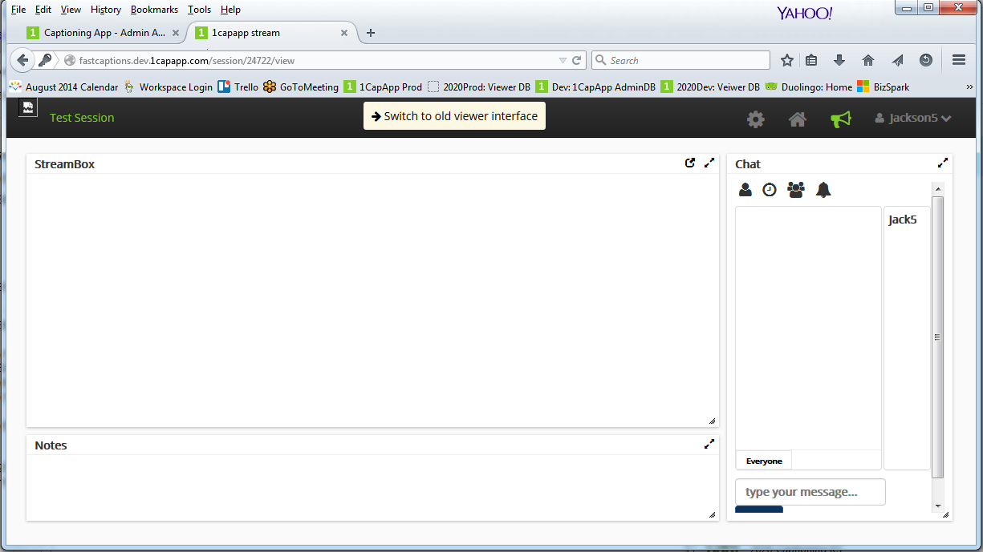
Go to full screen by clicking this icon:
Go back to the Viewer Dashboard Home Page:

And finally Log out:

The Icons above the Chat Box:

Sound Options

Show/Hide Chat User List

Show/Hide Times

Chat Nickname

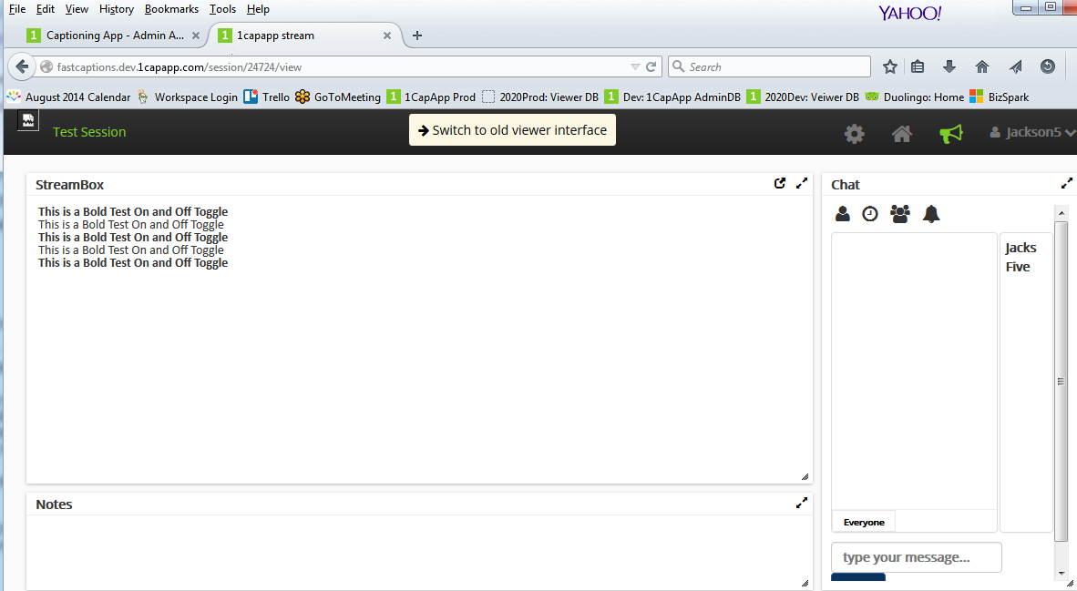

Highlighting in the StreamBox:
When you select text in the StreamBox a box will pop up that will allow you to:
Drop Icon: Highlight
A: Font Color
U: Underline
S: Strickthrough
B: Bold
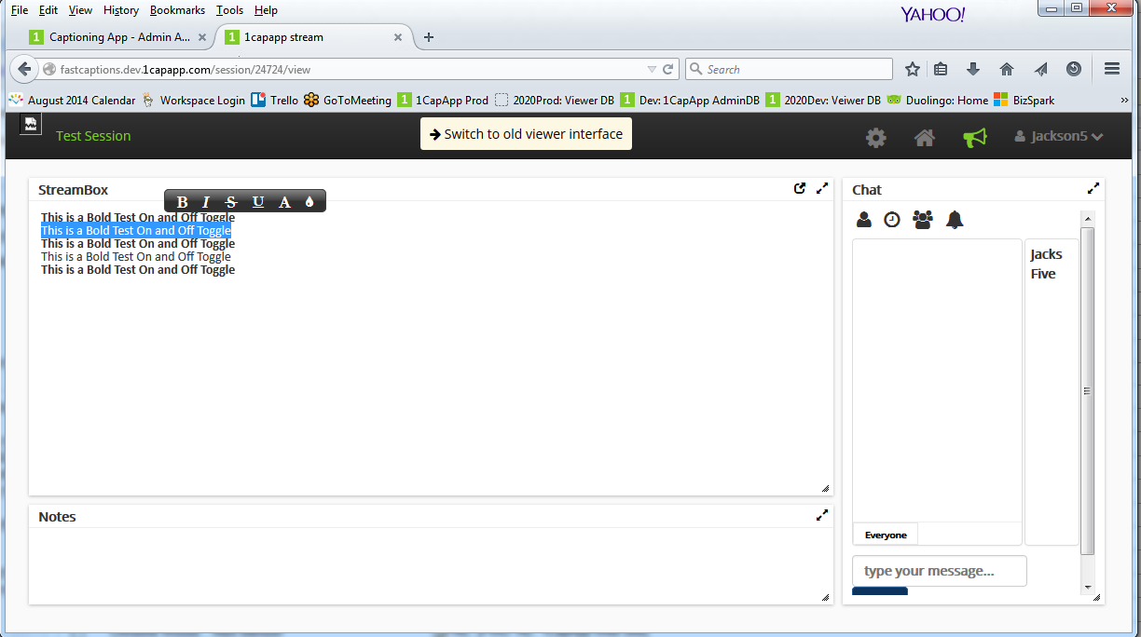
Selecting either the Drop/Highlight or the Font Color another box will display for you to choose a color


