NoteEd Setup with 1CapApp

To start a session.

1Connect
Download and install 1Connect: http://1connect.1capapp.com/1Connect.msi

Click on the link above to download 1Connect.
Run the downloaded file: 1Connect.msi.
This will install 1Connect on your computer.
You will be asked to reboot/restart your computer. This is necessary !!!.

After you have installed 1Connect and have restarted your computer:
- Click on the 1Connect desktop icon to bring up connection box.
- Select ComPort 9 (or an available comport) and click to connect.
- The three Lines should turn green.
1capapp: OK (1capapp.com – Secure Connection)
COM Port: Listening on COM port 9
TCP/IP Server: Listening on 127.0.0.1 port 6969

If the 3rd line does not turn green, no worries, if you are using the com port connection.

For NoteEd
- Open NoteEd
- Under View select One Line entry
- Under Tools click on Text Stream
- A box will come up for you to select a ComPort
- Ensure the same ComPort is selected as displayed in the 1Connect text box.

Click ok.

Continued below

You will not receive any notification that this has worked; but if it doesn’t work a box will appear to let you know that it was unable to connect. So no news is good news.

- When 1Connect and NoteEd are connected on the same ComPort go to www.1CapApp.com
- Log into 1CapApp with your user and pass
- Click on the Setup Sessions icon to take you to the scheduled session.

Find the next session that you are assigned to and click anywhere on the session line to display more info about the session.

When you are ready, click on the green Start icon on the left of the screen under Viewers.

After you have started the session, the status will turn to standby. When you start writing in NoteEd, the status will turn to Active and the color will be green.

Do not click on Interactive Stream. This is used as a different way to connect and cannot be used in conjunction with NoteEd.

The client should see the text on their view page.

Click on View to display the view page and chat box.
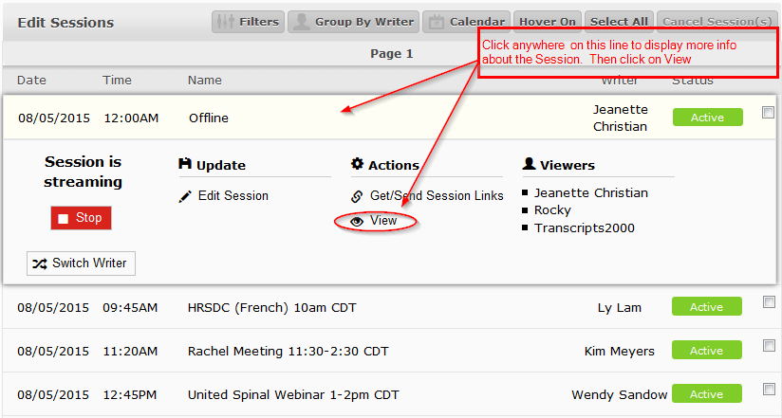

The following view page will display with the Chat Box where you can communicate with the client.

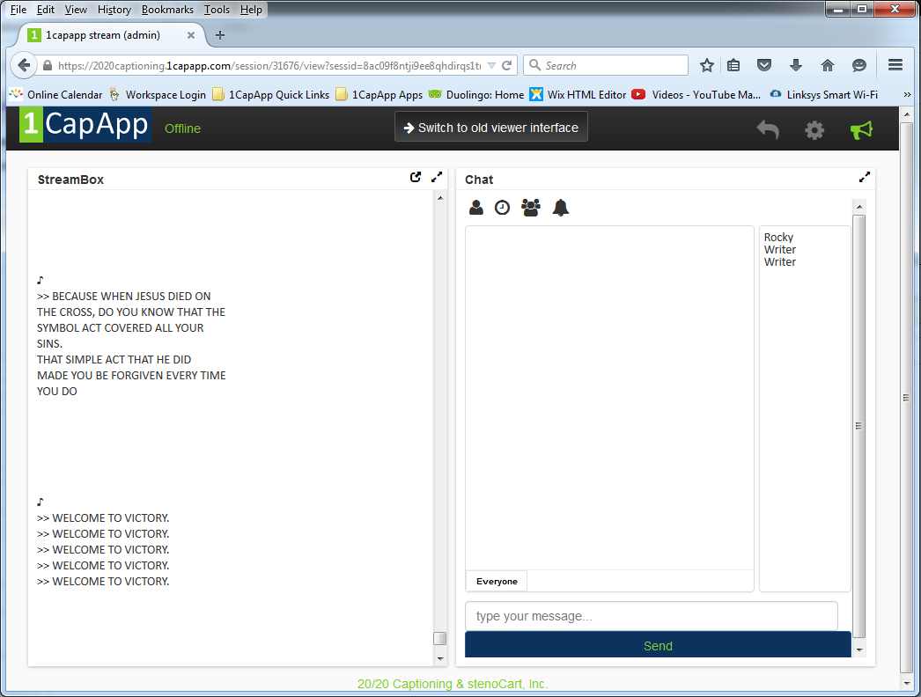

After the session
You must stop the stream

In the StreamBox window, on the top right you will see a large grey return arrow. Click on the return arrow and you will return to the window that displayed the session details.

Click anywhere on the session line again and more info will appear.
Click the big red Stop button to stop the session. This will also disconnect you 1connect connection.

