ProCAT Users:

If you are a new company to 1CapApp:
Register at http://1capapp.com

If you are a writer working for a company already registered with 1CapApp then
Login with your proved user and pass.

At the homepage you will find a link to download 1Connect: Download and install 1connect

http://1connect.1capapp.com/1Connect.msi

After installing the 1Connect software on your computer.

Create a session on 1CapApp
Start the session
Start 1Connect (Double click on the 1Connect icon)

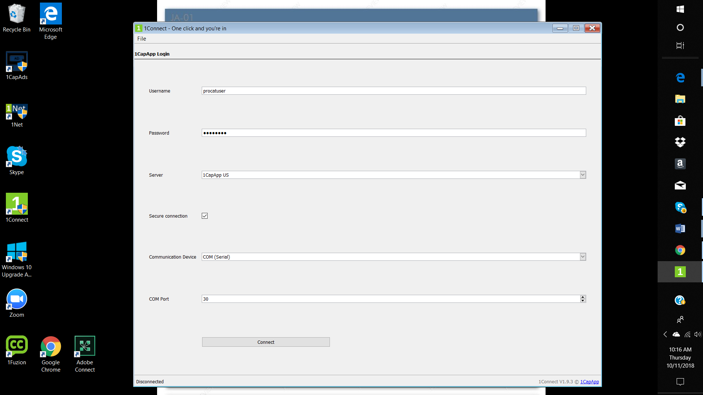

Input your user and pass
Be sure to check the Secure Connection check box
Communication Device will be Com (Serial)
Com Port number will be 30
Open ProCAT

Go To the Realtime Translation Menu
Select Preferences
Select Workstation

Find “Port Assigned to Counsel” There will be the dropdown menu with port numbers.
Choose the same com port, port 30, you used for 1Connect and click "okay."
You may need to input a port for a TCP/IP and that will be 6969.
Do not change any baud rate, parity, stop bits or data bits.
Under "Workstation Software/ Protocol, choose "Plain ASCII."

