Setup using 1Connect and Rapid Captions

Setup the 1CapApp session:

Step 1: Register or Sign in to 1CapApp
If you are new to 1Capapp, go to: http://1capapp.com and click Register to setup your account.
If you are working for another company, sign in with the user and pass provided to you.

Step 2: Download the 1Connect software
Download and install 1Connect (located on the home page of your 1CapApp account
If you have Serial IP that you have purchased (from Tactical Software) you will not need to download 1Connect, however, you may find 1Connect easier to use.

Step 3: Create or Start the live streaming session
Go to Setup Sessions and create your session or find the session you are assigned to. Click anywhere on the session line and more information about the session will appear including the “Start” button.
Click the start button. Be sure you are assigned to the session as the writer.

Setup for Rapid Captions:
Step 1
- At Configure Devices
- Add a new Device
- Connect should be “Connect via TCP/IP
- Description: 1CapApp
- Address: 127.0.0.1
- Port: 6969
See Screen show below
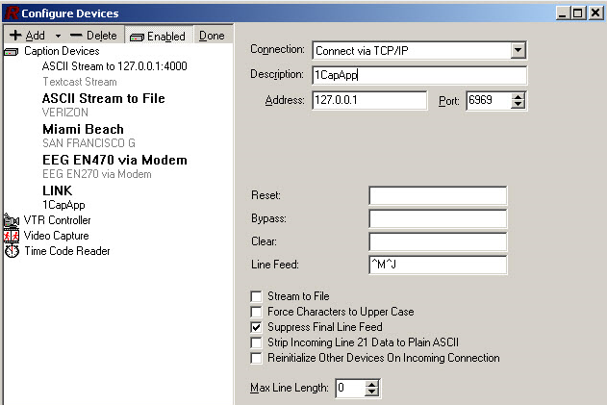

Lets Get Started!

Step 1
- Schedule a job in 1CapApp
- Make sure you’re assigned as the writer on the session created in 1CapApp
- Start your 1CapApp session manually or allow the session to start at the scheduled time

1Connect
Step 2
- Double left click on 1Connect and the below box pops up
- Fill in the username/password you created on 1CapApp as the Writer. It is case sensitive.
- Pick USA Server.
- Click Secure Connection
- Since we are using TCP/IP the Com Port is not used, so put anything 45 works
- Fill in TCP/IP Port: 6969
- Click Connect
- When you click connect you will see the session you are assigned to in 1CapApp.

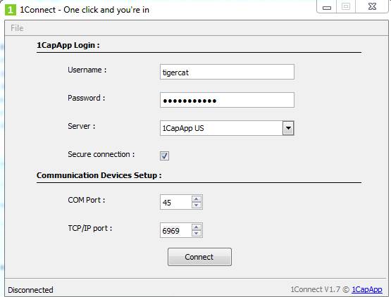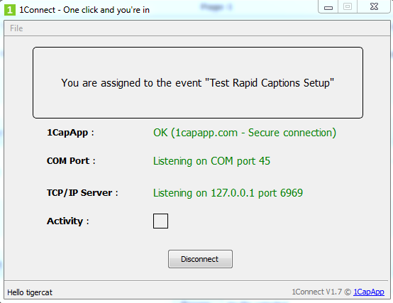

Eclipse Software
Step 3
- Start a new realtime job
- Start voicing or writing

To View Text Streaming in 1CapApp
- Go to your Admin Dashboard: www.1capapp.com user/pass that you use to enter the dashboard of 1CapApp
- Left click anywhere on your session
- Under actions tab click view

