How to Use Tactical Software Serial IP with 1CapApp in USA Server

Step 1:
Schedule a session in the 1CapApp platform. If you are unsure how to do this go to
Resources|Documentation|Setup Document

Step 2:
Open Serial IP Control Panel on your computer.
- Pick COM# to match your COM output in your CAT software. COM18 is only an example.
Step 3:
Username and Password
- Create user/pass in the 1CapApp platform under Admin|UserControl|Writer.
This user/pass is what you enter here (case sensitive).

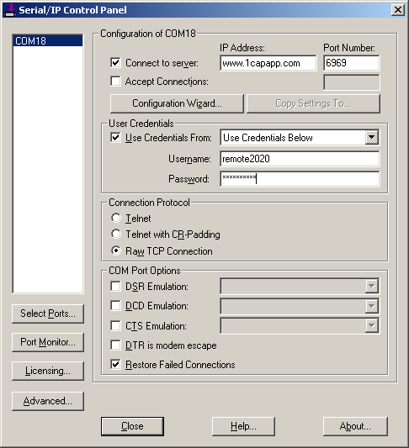

Step 4:
Fill out the rest of the information for Serial IP Control Panel. Click Configuration Wizard circled above in red.

Step 5:
Click Start circled below in red. Serial IP will run through a conversion.
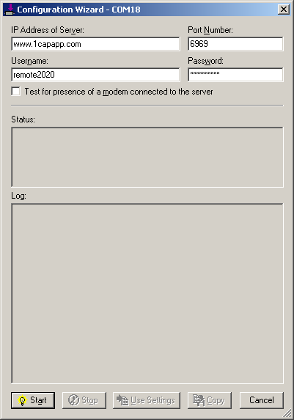
Step 6:
If configured correctly, you will get all green checkmarks as indicated below. You can now click the x (upper right-hand corner) and you are ready to go.
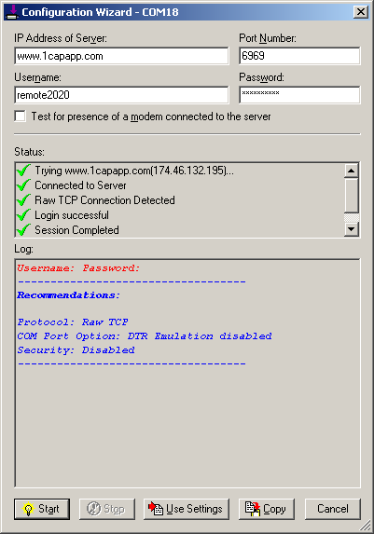
If you have a session scheduled in 1CapApp it will display it in red where you see the words, Username and Password to the left:
Step 7:
CAT Software
Open your realtime software
- Make sure your realtime output Com Port is the same as in Step 1 above.
- Open a new realtime job
- Start writing
Step 8:
For Writer to VIEW session with client go to:
- http://1capapp.com/login.php
- User/pass (what you typed into Step 3)

