If you receive an error when setting up a new computer bought in 2023 or later do this:

Disable Core Isolation feature.

Go to Windows Security
Device Security
First one is "Core isolation"
Click to disable.

reboot
clear cache
Thank you

Screenshots demonstrating how your settings should look.
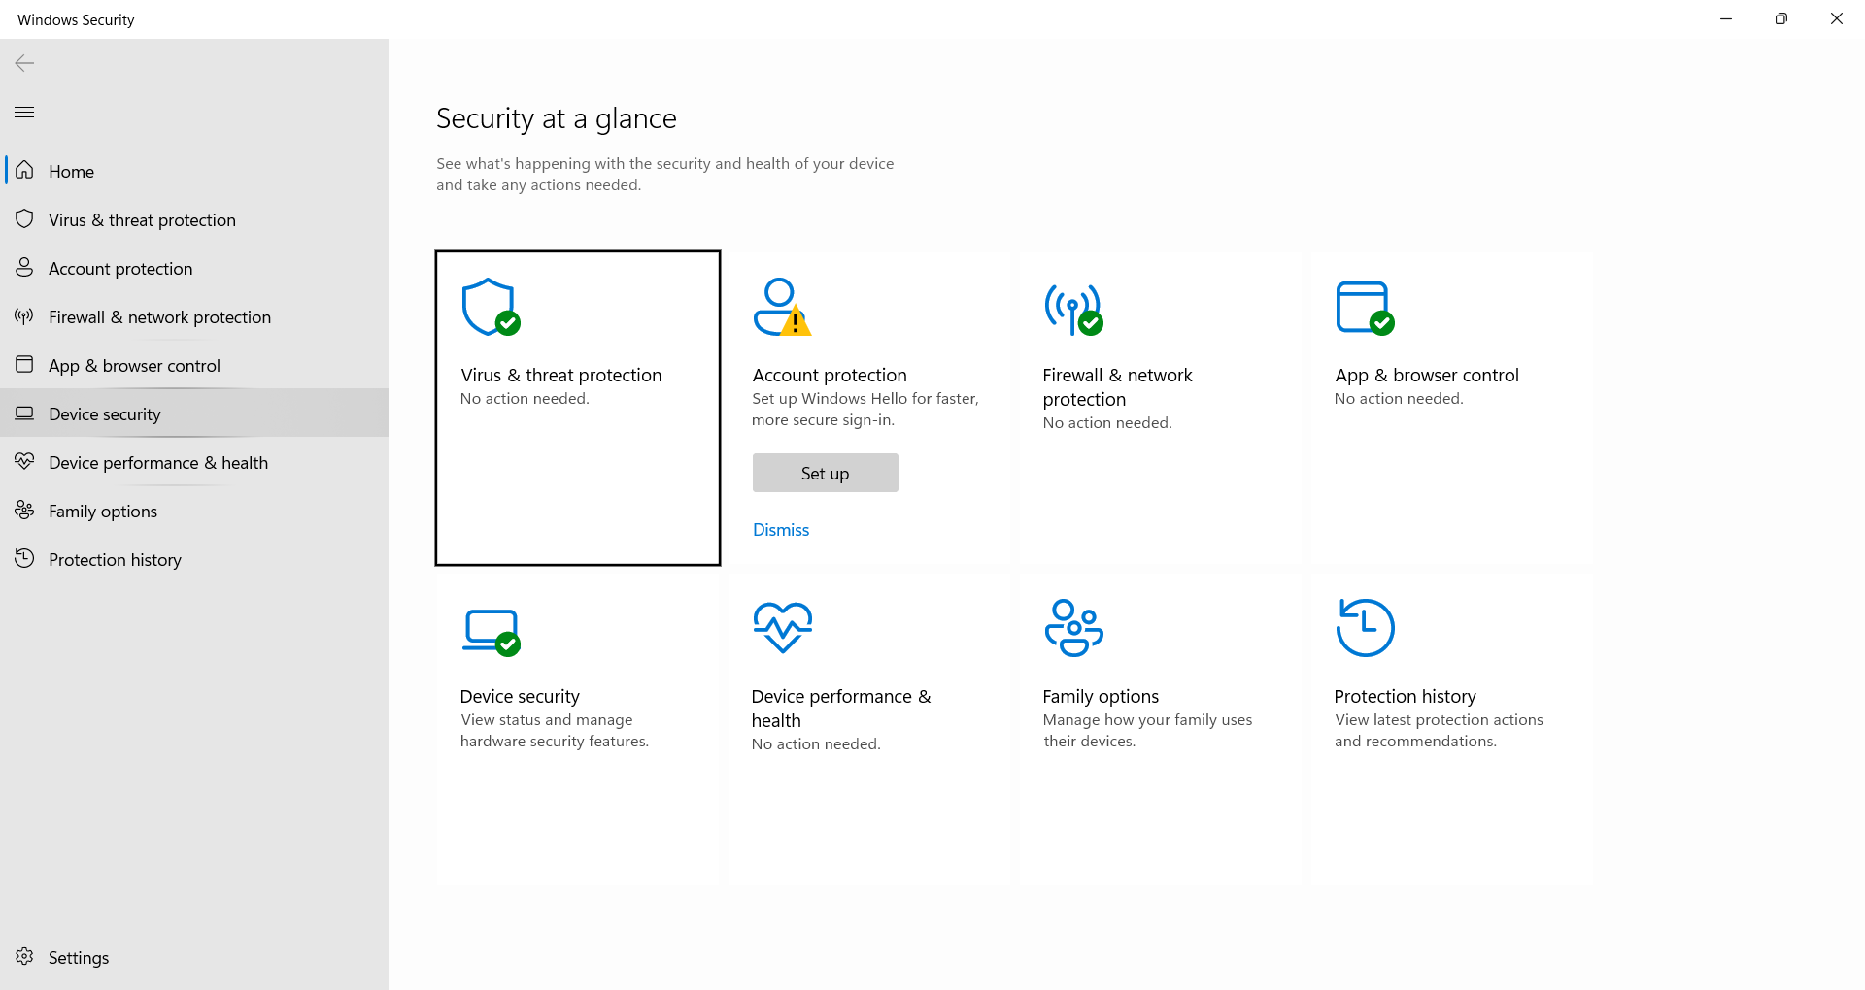

Click Core Isolation Details
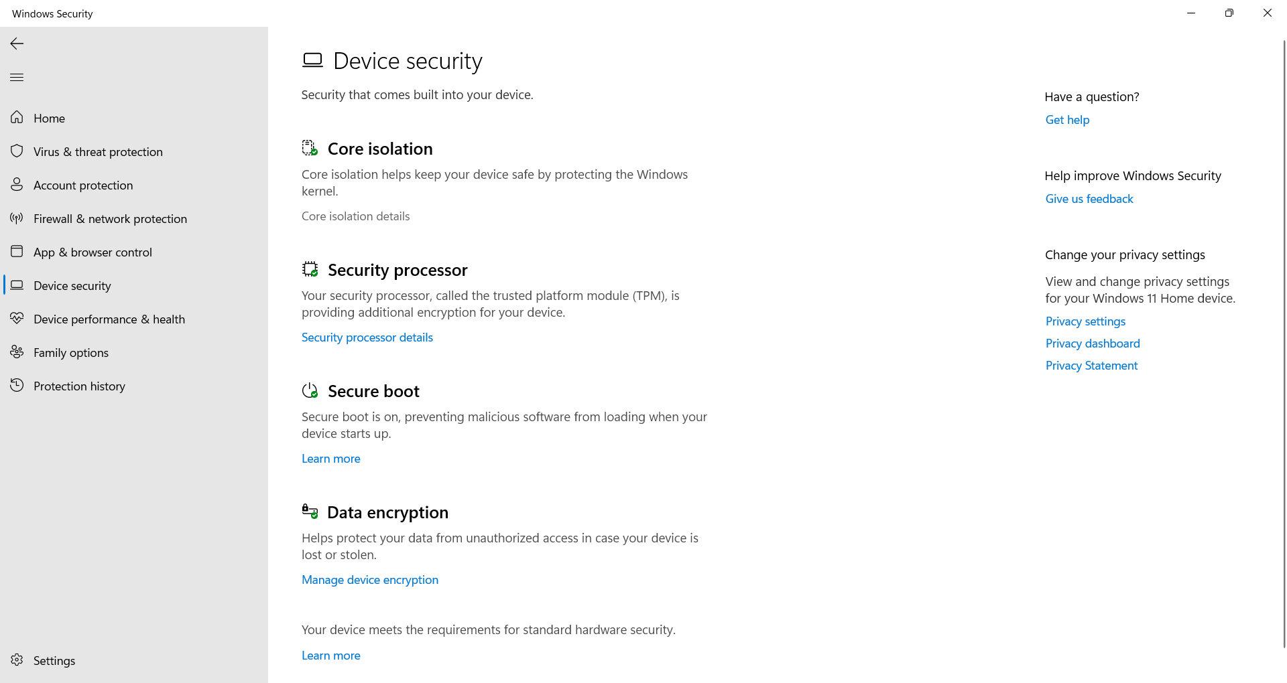

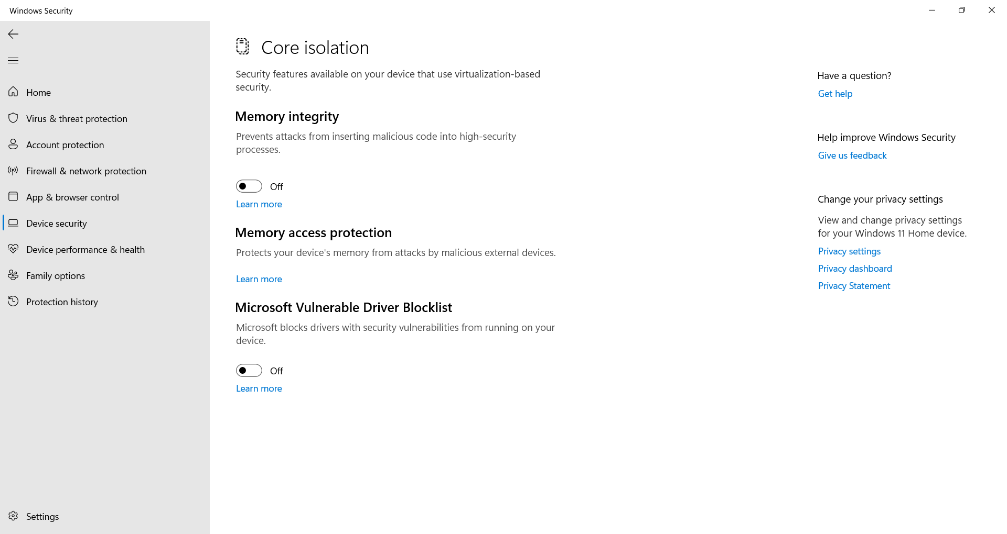
Note: What you see on the Core isolation page may vary a bit depending on what version of Windows you’re running.

